Press Release

PRAGUE, 24/02/2009 – Internet advertising announces 5 billion crowns for last year

In 2008, the Internet collected a total of 5 billion crowns from Czech advertisers and internet media operators estimate a year-on-year growth of almost 26% for this year. Within the area of banner advertising, advertisers last year invested 3.3 billion crowns in the internet, in search advertising 1 billion crowns, and in directory advertising 0.75 billion crowns in the list prices (gross). The internet’s share as a media type thus reached almost 9% of the total investments in advertising for 2008 in the Czech Republic, and is in third place right behind television and print media. This is information learnt from research implemented by the independent research agency Factum Invenio for the Internet Advertising Association (SPIR).
The overall advertising performance for last year is made up of parts measured by the AdMonitoring project, which registers the campaigns for banner advertising (i.e. display advertising) in standard formats. The performance of other forms of internet advertising – non-standard display advertisements, search ads, and directories – arose based on the declared performances of individual content providers directed by the research agency, Factum Invenio. The absolute performances of individual types of advertising and their distribution in 2008/2009 can be found in graphs 1 to 4.

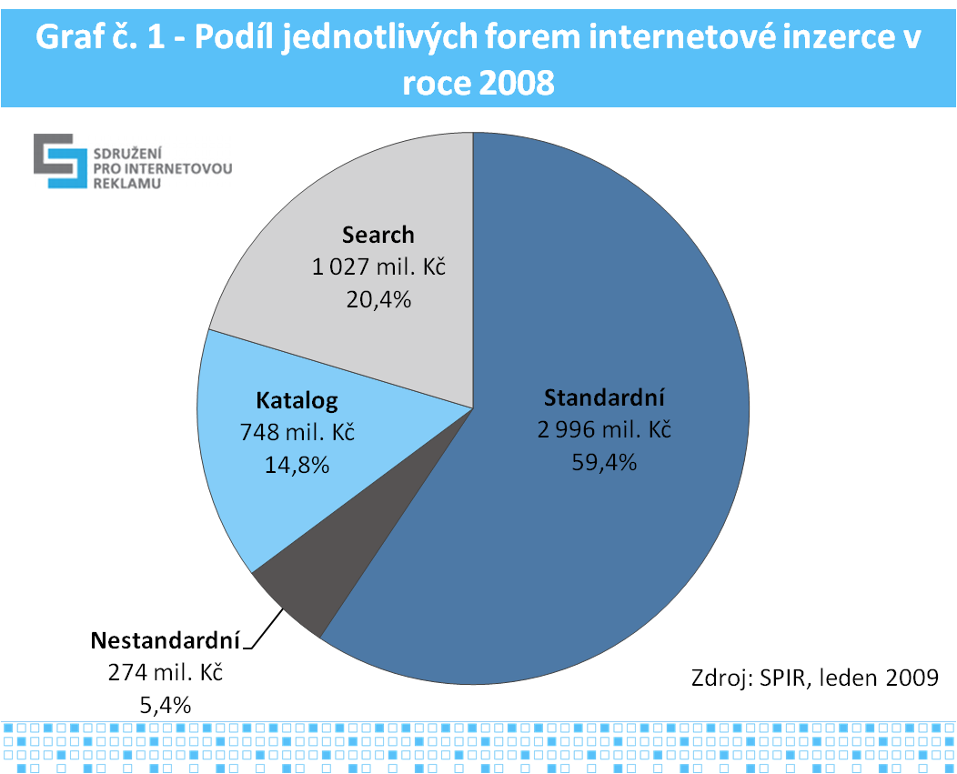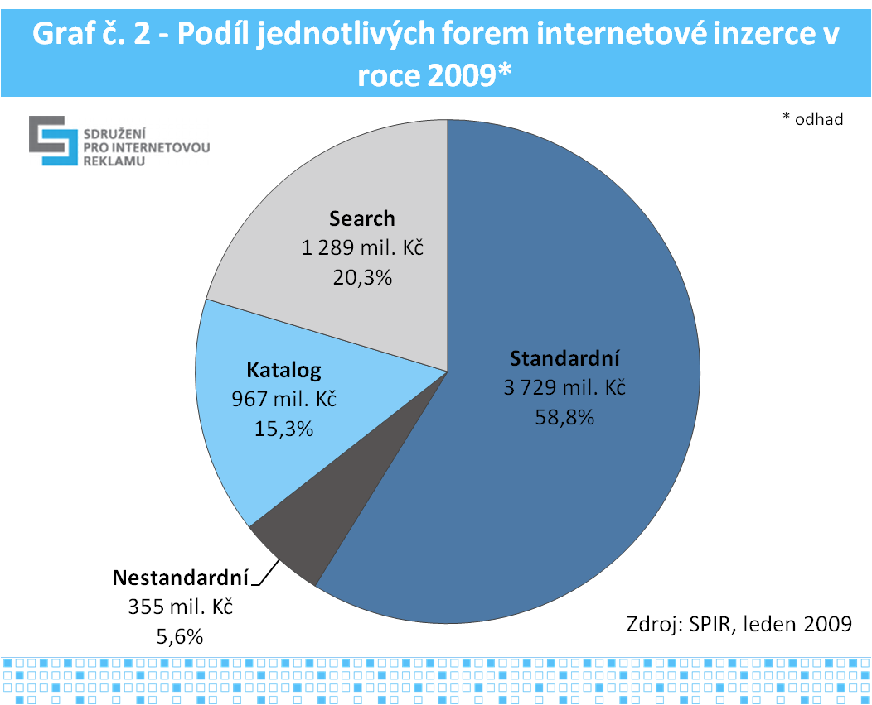
Graph 1 – Share of individual forms of internet advertising in 2008
Graph 2 – Share of individual forms of internet advertising in 2009
Search / Directory / Standard / Non-standard
CZK...m xx.x%, Source: SPIR, January 2009
* estimate

The majority is taken up by display advertising, which is the most important for advertisers, this apply also to the following year. Due to the current crisis in all branches, over 25% of the estimated increase in volume of internet advertising can be regarded to be some of the first positive news for our advertisers. “The numbers given represent the clearest possible view of the overall state of internet advertising currently, because they come directly from the overwhelming majority of the SPIR membership base and their group and the evaluation was done by an independent agency. From the research it is clear how strongly the internet’s position has shifted. Its importance already exceeds the majority of traditional media types,” commented Jan Simkanic, chairman of SPIR, on the results.

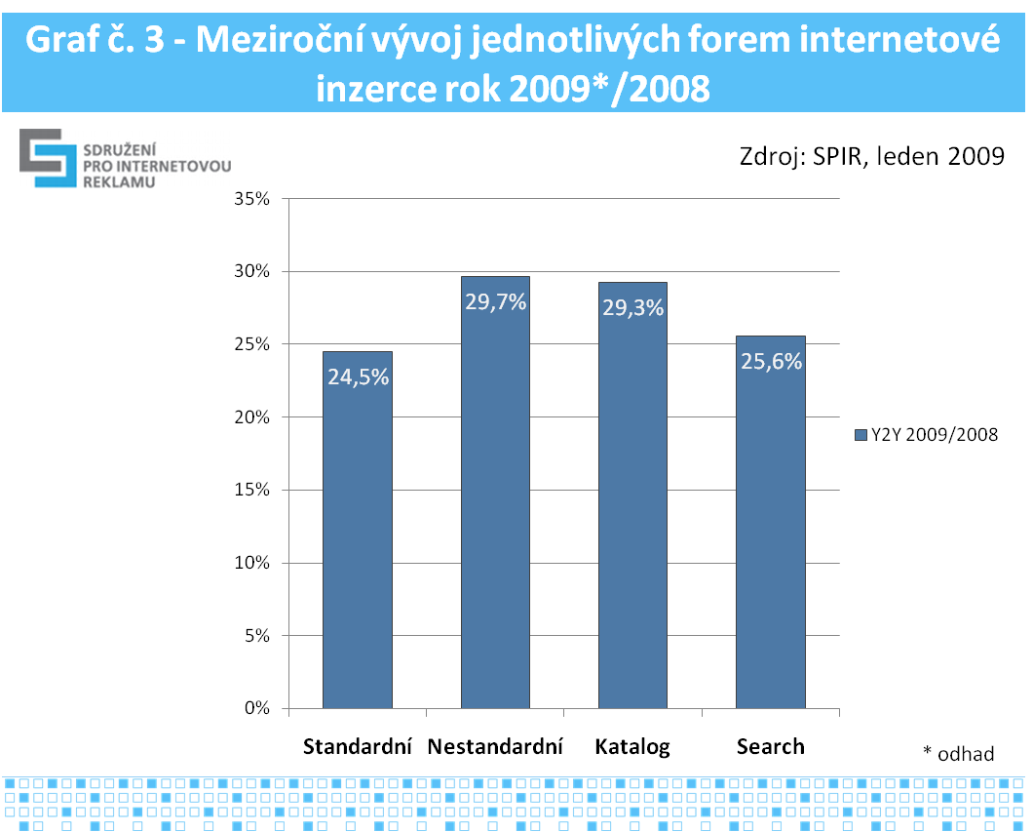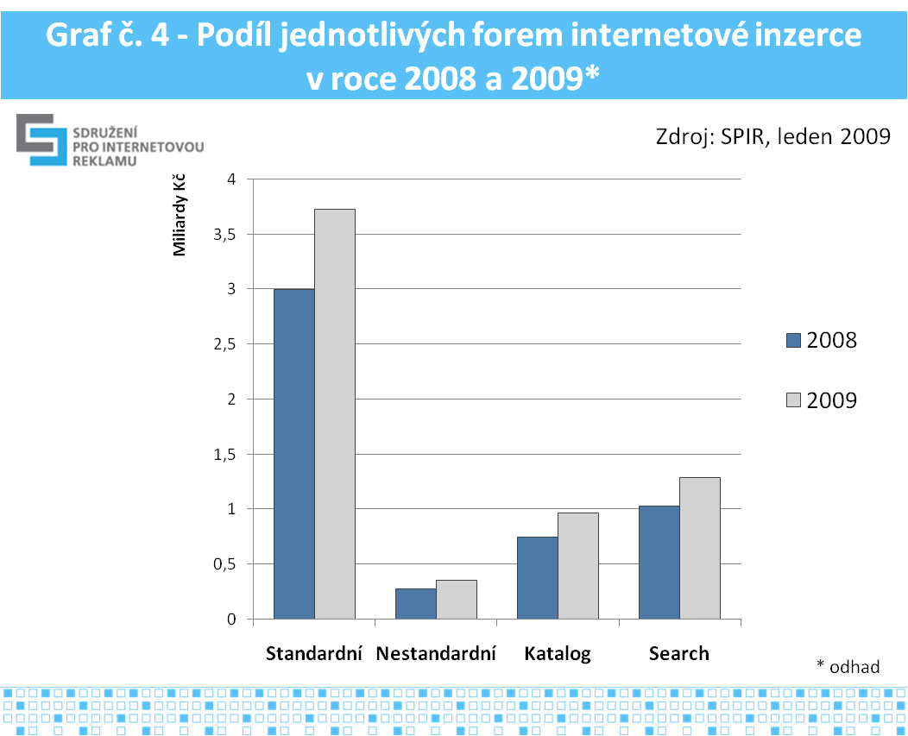
Graph 3 – Year-on-year development of individual forms of internet advertising for 2009*/2008
Graph 4 – Share of individual forms of internet advertising in 2008 and 2009*
Source, SPIR, January 2009
xx.x%, Standard / Non-standard / Directory / Search *estimate

If we compare advertising performances of the internet with the performances of other media (graph 5, in list, so called gross prices), which comes from monitoring of advertising performances by the company TNS MI, then the internet as a media type has taken third place behind television and print media with 5 billion crowns. Other media, such as radio, outdoor and cinema is following behind.

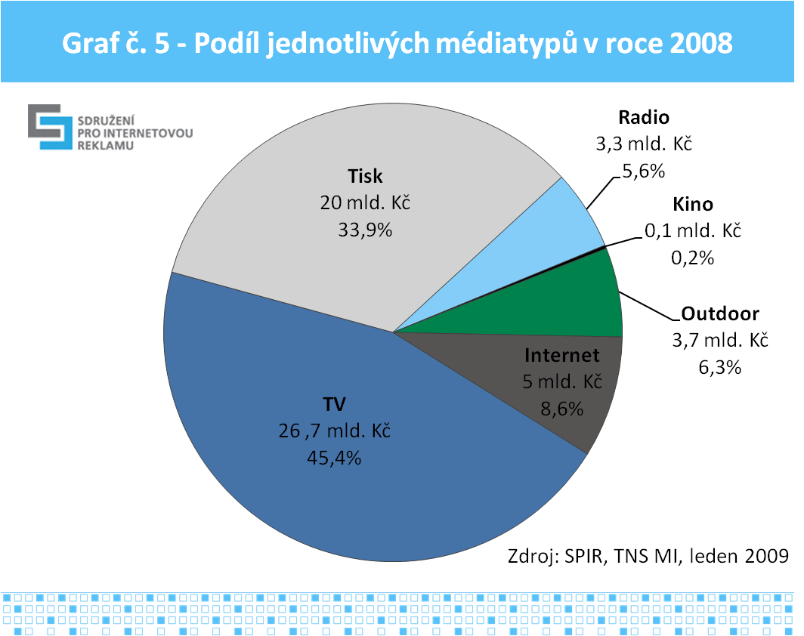
Graph 5 – Share of individual media types in 2008
Radio / Cinema / Outdoor / Internet / TV / Print media
CZKxx.x billion, xx.x%
Source: SPIR, TNS MI, January 2009

Description of the methodology: the processing of the results was, in the interest of objectivity and the protection of sensitive data, entrusted to the agency Factum Invenio. The investigation took place during the first half of January 2009, therefore based upon the current half-year balances of individual subjects. From the 34 companies approached, who are internet advertisers in the CR, 19 subjects took an active part. Returns of 55.9% are, for such an investigation, unusually high. It is also important that the companies whose turnover makes up a major share, mostly contributed actively. So thanks to this, the results presented can be regarded as credible. The subjects who did not take part are included in the aggregated data with a qualified estimate (more precise data from AdMonitoring and also based on information about the formats of internet advertising, on which it they focus specifically).

A description of the forms of internet display advertisements can be found here.

SPIR is a professional association working in the area of internet advertising since 2000. It consists of two sections, representing both sides of the advertising market – the internet media section and the internet advertisers section. At present, the membership base of the association consists of a total of 53 members in both sections. In addition to the operation of unified and widely respected monitoring of visitor rates and socio-demographic profile of internet visitors, NetMonitor, it also executes an internet advertising monitoring project, AdMonitoring, the IAC professional conference on internet marketing, and provides expert analysis of the development of the Czech internet market.

For further information contact:
Kateřina Hrubešová
SPIR Chief Executive
Tel: 224 251 250, 777 306 151
Email: katerina.hrubesova@spir.cz

Jitka Černá
Marketing & Event Manager
Tel: 224 251 250, 777 151 482
Email: jitka.cerna@spir.cz

