|  |
| --- |
| **Audit of Internet Traffic** |

netmonitor_logo_cmyk_vektor.wmf

## **Trends in Internet Traffic**

**Yearbook 2012**

**January 2011 – February 2013**

[www.netmonitor.cz](http://www.netmonitor.cz)

[www.spir.cz](http://www.spir.cz)

Trends in Internet Traffic

The Internet is used by 69 % of the Czech population 10+ of age, (at least once a month they visited a measured server), which is about two and a half more than last year. In the last two years, the number of people using the Internet rose on average by a rate of 5 % a year. With young people of 10-24 years, the rate of Internet penetration is over 90 %, and the Internet population in this age category almost does not have where to grow. With rising age, the percent of people using the Internet drops. The penetration of Internet of people older than 55 is 34.9 %, which is 4.4 percent more than the percentage last year. Here exists great potential, and the greatest growth will continue exactly in this age group. There are more men than women on the Internet, and with increasing age the proportion of men rises and the proportion of women declines. This difference between genders will decrease with a rising Internet population. On average, men are slightly more active on the Internet than women in the number of page views and average time spent there (ATS). The average Czech Internet user is younger and more educated than the average Czech citizen. Most internet users have secondary education with a diploma. Users of the Internet spend most of their time in the categories *of Home pages, Databases and catalogs.* Social networks (from abroad) in the last year in our country continued to rise, mainly Facebook. Other phenomena in our country remain auction and discount servers, which are now taken as a common online activity. The proportion of accesses to web services through mobile phones and tablets is rising at high pace.

Internet Users Versus the General Population

In February of 2013, the size of Internet population 10+ reached 6.5 million people In comparison with general (real) Czech population (10.5 million) it involves 62 % of all residents. In order for the comparison to be meaningful, however, we must compare the mentioned Internet population older than ten years with the general population in the same age structure (9.4 million). In this case, the Internet population (10+) forms 69 % of the general population of the Czech Republic (10+).

Shown in graphs No.1 and No.2 is a comparison of the age structure of general and Internet population in absolute numbers and percentual share. In the age category of 10-24 years, there are 90 % of people. With increasing age, the proportion of people on the Internet decreases. Only 34.9 % of people over 55 use the Internet. In the general Czech population, the 55+ age group has the largest representation (34 %), but in Internet population this age group has only a 17% share.

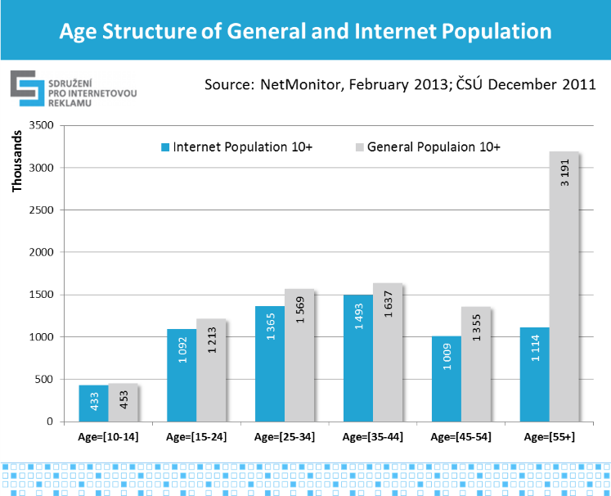 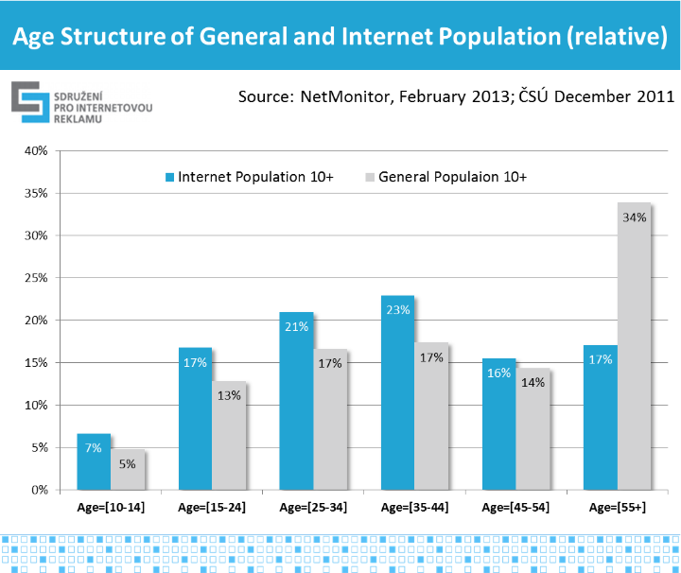

Graphs No.1 and No.2, source: NetMonitor – SPIR – Mediaresearch & Gemius, 2/2013; ČSÚ (Czech Statistical Office) 12/2011

Graphs No.3 and No.4 show the composition of individual age groups of the general population and of the Internet population according to gender. The gender share of the general population is balanced, only the oldest group is strongly dominated by women because they statistically live longer. With the Internet population the dependence is totally opposite. With increasing age, the proportion of men increases, while the proportion of women decreases. This is due to the greater technical enthusiasm for learning to use new technologies in senior men as opposed to senior women. Over time, this phenomenon will start to fade away, because people who already use the Internet will not stop using it as they age.

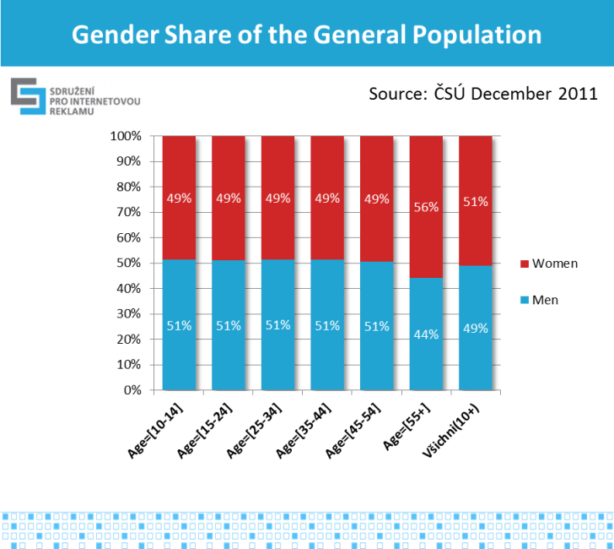 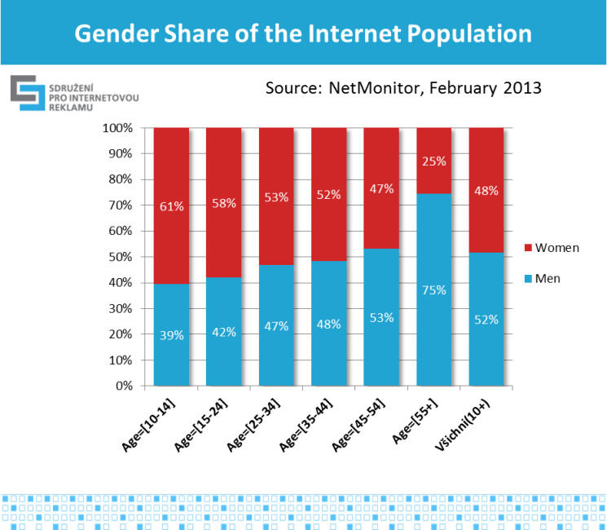

Graphs No.3 and No.4, source: NetMonitor – SPIR – Mediaresearch & Gemius, 2/2013; ČSÚ 12/2011

Graph No.5 shows a comparison of the Czech general population and Internet population from the viewpoint of the highest attained and completed education. The Internet population has a noticeably higher education level than the general. The majority (63 %) of Internet users 15+ have secondary education with a diploma or higher education level, in the Czech general population 15+ it is 49 %. Most Internet users 15+ have secondary education with a diploma (40.4 %). In the general population, the highest proportion have people who have secondary education without a diploma (35.1 %).

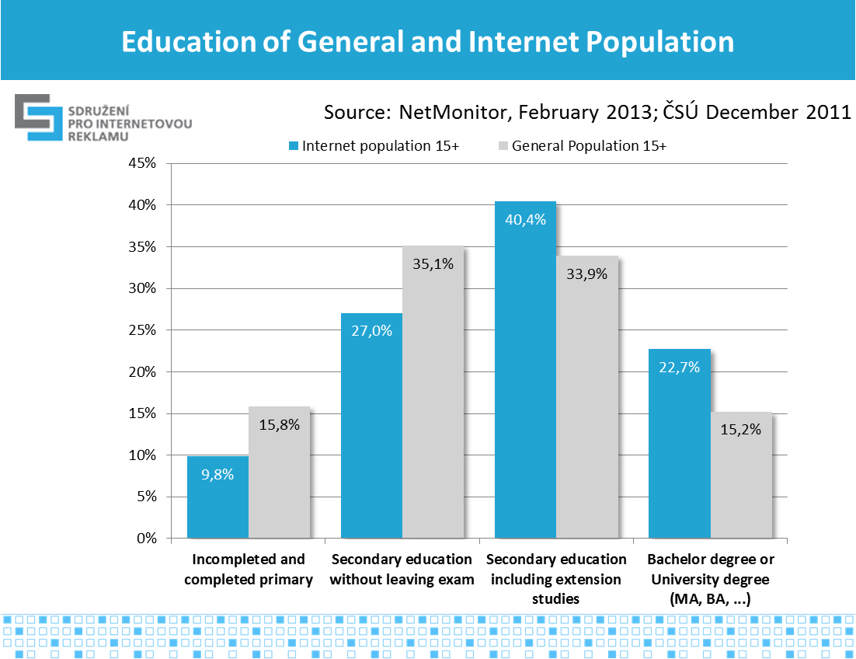

Graph No.5, source: NetMonitor – SPIR – Mediaresearch & Gemius, 2/2013; ČSÚ 12/2011

The Trend in the Number of Measured Media

Graph No.6 illustrates the trend in the number measured Internet media (servers). In February, the number of measured media reached 547 servers from 51 operators. The average monthly growth rate of the number of measured servers is 1.5 % (M2M, from the beginning of 2008).

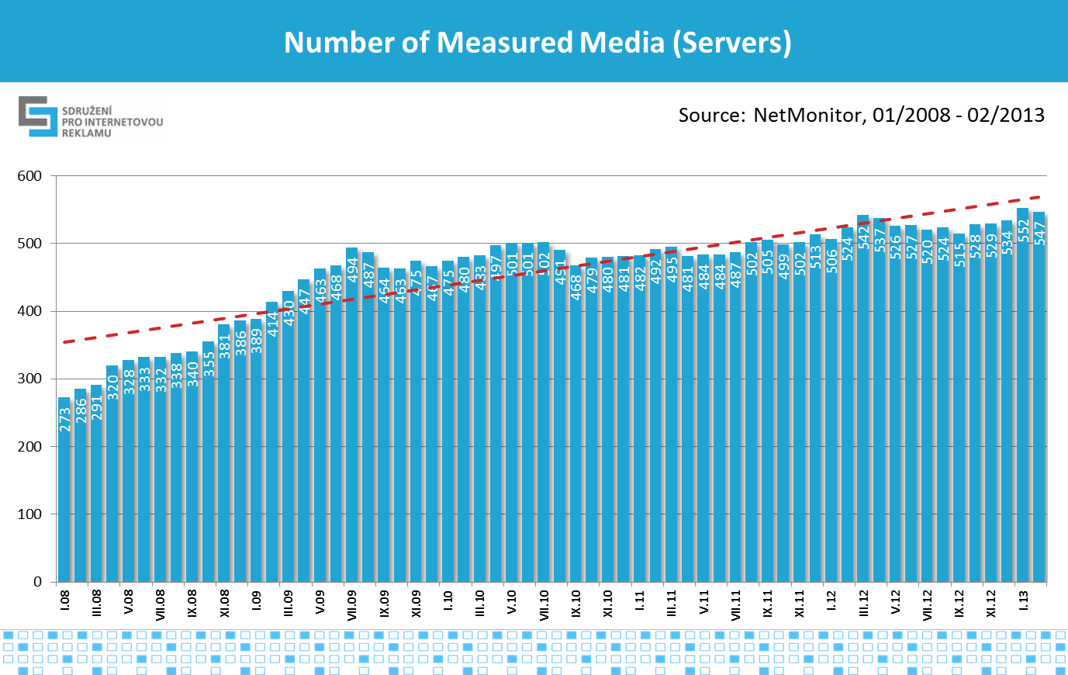

Graph No.6, source: NetMonitor – SPIR – Mediaresearch & Gemius, 1/2008-2/2013

The Trend in the Number of Internet Users (RU)

The number of Internet users (RU) is the number of Internet users in a particular target group, who generated at least one view on the chosen web server during the given month. This indicator corresponds with the actual number of people (not computers, cookies or IP addresses), who visited the web server in the given month. Graph No.7 shows the trend in the number of Internet users in the Czech Republic from the beginning of 2011. Observable are traditional seasonal fluctuations – declines in the course of summer holidays. In February 2013, the number of Internet users from the Czech Republic was 6.51 million. Since January 2013, NetMonitor, thanks to a fused panel, is able to measure the entire Czech Internet, reaching thus from the current 97.7 % to 100 % (in graph shown in the green columns).

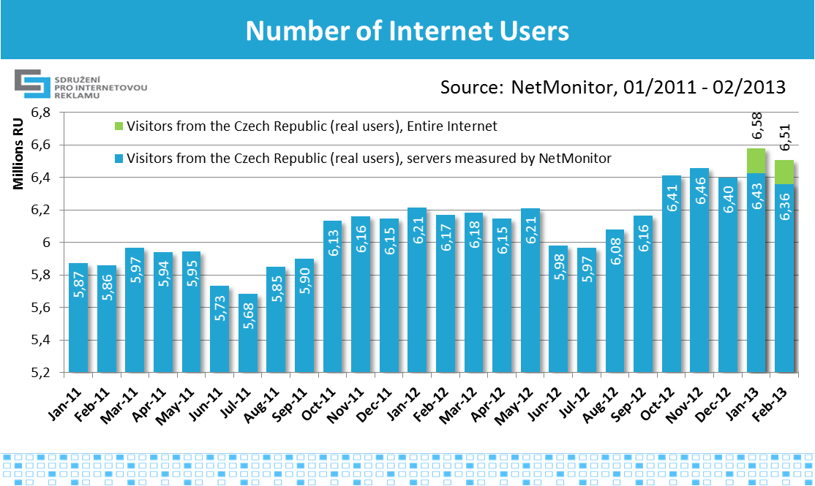

Graph No.7,source: NetMonitor – SPIR – Mediaresearch & Gemius, 1/2011-2/2013

There are more men on the Internet. In February 2013, the ratio was 51.8 % men compared to 48.2 % women. Graph No.8 shows the trend of the absolute number of men and women from the Czech Republic on the Internet. The ratio of men and women on the Internet in the long term is in balance.

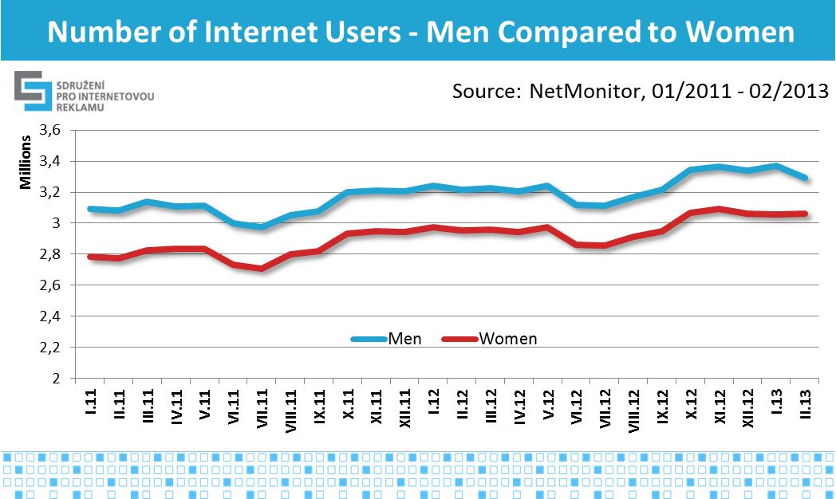

Graph No.8, Source NetMonitor – SPIR – Mediaresearch & Gemius, 1/2011-2/2012

The Trend in the Number of Page Views (PV)

Page views (PV) are views (downloads) of www documents from the particular web server into the browser of the visitor. The trend in the number of PV is illustrated in graph No.9, and how repeatedly the number of users and seasonal fluctuations and other influences manifest themselves. The absolute record is January 2013, when the number of page views on connected servers reached 9.3 billion. With the projection of the software part of the fused panels we can, since January 2013, deduce the number of viewed pages on the entire Czech Internet by Czech users (in the graph in the green columns).

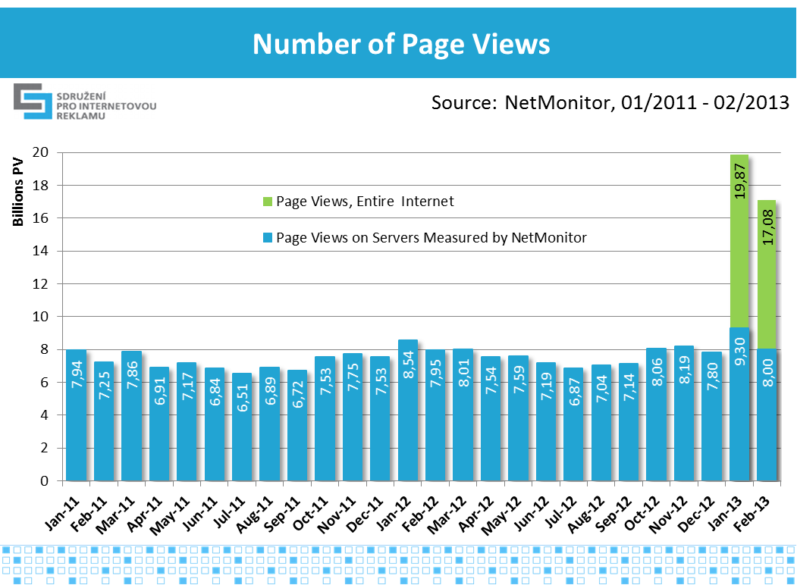

Graph No.9, source: NetMonitor – SPIR – Mediaresearch & Gemius, 1/2011-2/2013

Graph No.10 shows the trend in the number PV depending on the gender of the user. The ratio of the number of viewed pages is slightly higher for men then their of the Internet population. Men are therefore more active on the Internet.

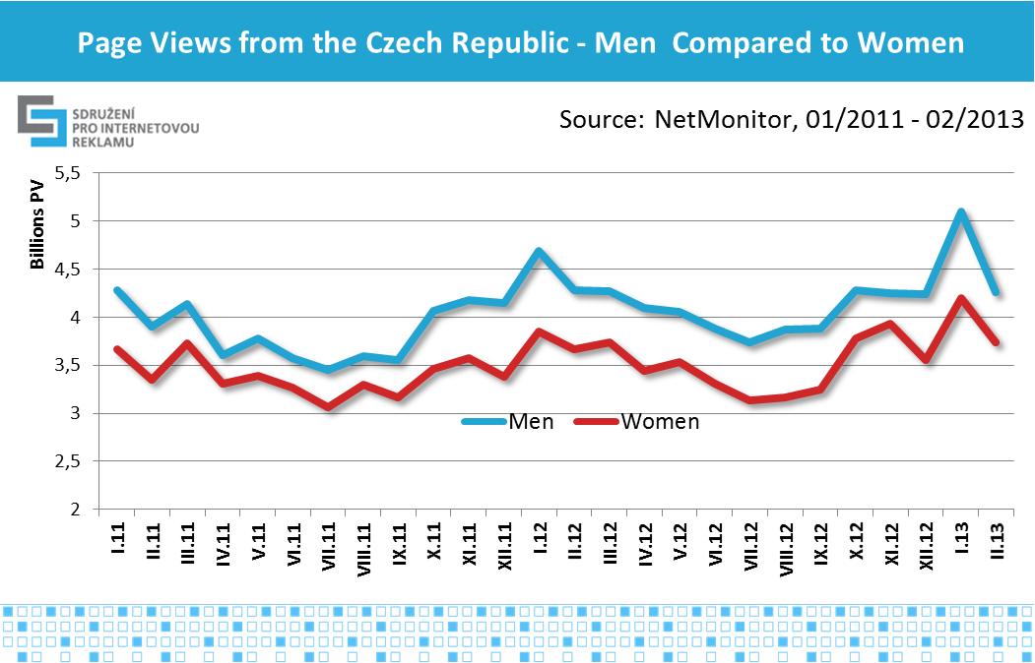

Graph No.10, source: NetMonitor – SPIR – Mediaresearch & Gemius, 1/2011-2/2013

The Trend in the Length of Average Time Spent by a Visitor (ATS)

The average time spent by a visitor is the total time spent by an average user (actual user) from the given target group on the selected web server during that month. Graph No.11 shows the trend of ATS on the Internet. The most time spent on measured websites by users was in January 2013 (30.5 hours per month). Since January 2013, due to the projection from the software part of the fused panel, we can judge ATS on the entire Czech Internet by Czech users (green columns in the graph).

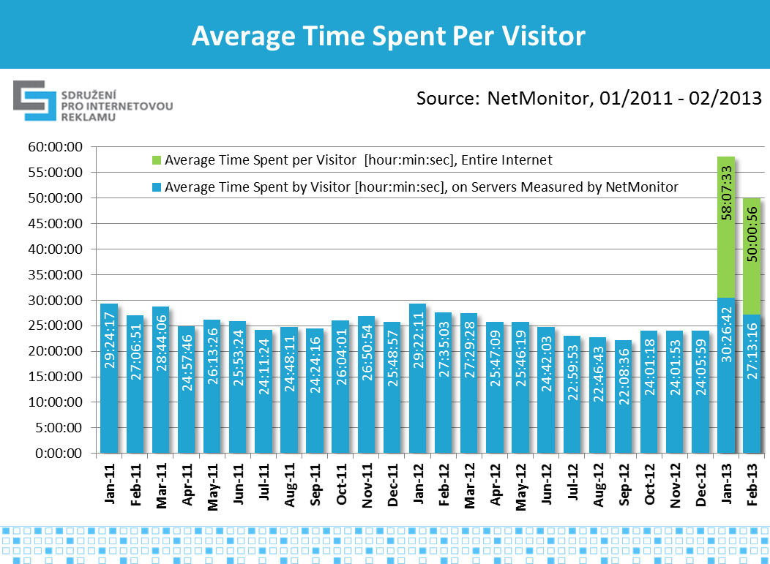

Graph No.11, source: NetMonitor – SPIR – Mediaresearch & Gemius, 1/2011-2/2013

Graph No. 12 shows the trend of ATS depending on the gender of the user. In February 2013, men spent on the participating servers on average 1:15 hours more than women. From a long term point of view, men have slightly higher ATS than women.

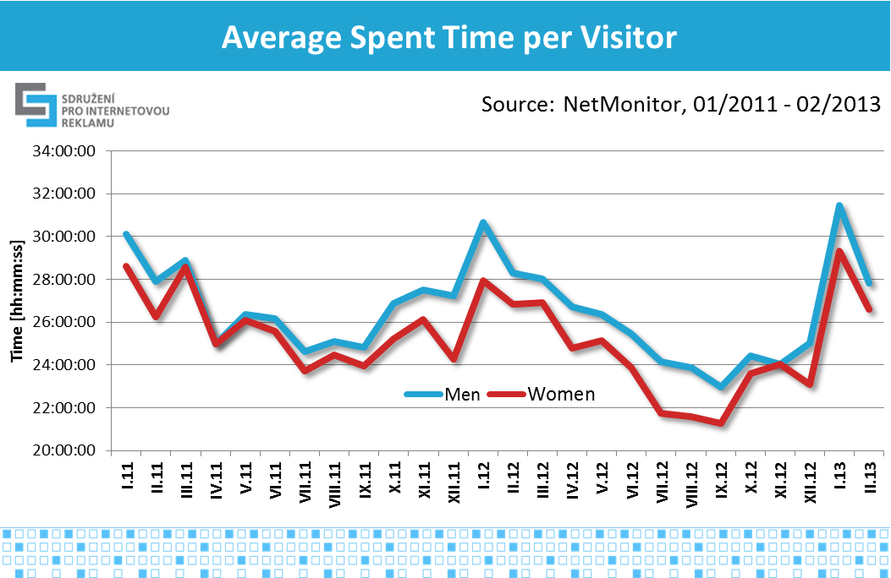

Graph No.12, source: NetMonitor – SPIR – Mediaresearch & Gemius, 1/2011-2/2013

Trend of Gender Share - Men Versus Women

Graph No.13 shows the trend in the gender share of users regarding their number (RU) and the number of page views (PV). Men tend to be more active than women, i.e., they view a greater share of pages than is their share in number. It is not a rule, however, as observation offered several hypotheses, but none of them were confirmed in the long term.

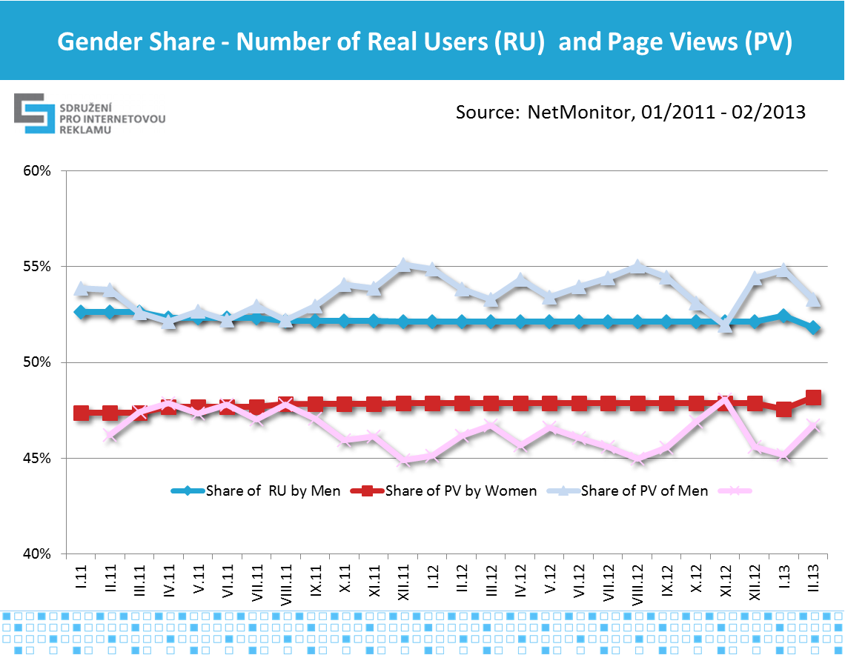

Graph No.13, source: NetMonitor – SPIR – Mediaresearch & Gemius, 1/2011-2/2013

The Age Structure of Internet Users

Graphs No.14 and No.15 show the trend in the age structure of Internet users in absolute numbers and percentage share. The graphs clearly reveal long term trends, where users over 35 are rising, while the most apparent growth is seen in the 55+ group. In other words, the Internet population is aging. The age category up to the age of 34 does not change in absolute numbers, but given the rising share of older age groups their share is declining. It can be further expected that gradually the share of older age groups will rise, as graph No.15 confirms with the age group 55+. With young people seasonal influences are most apparent – Summer vacation.

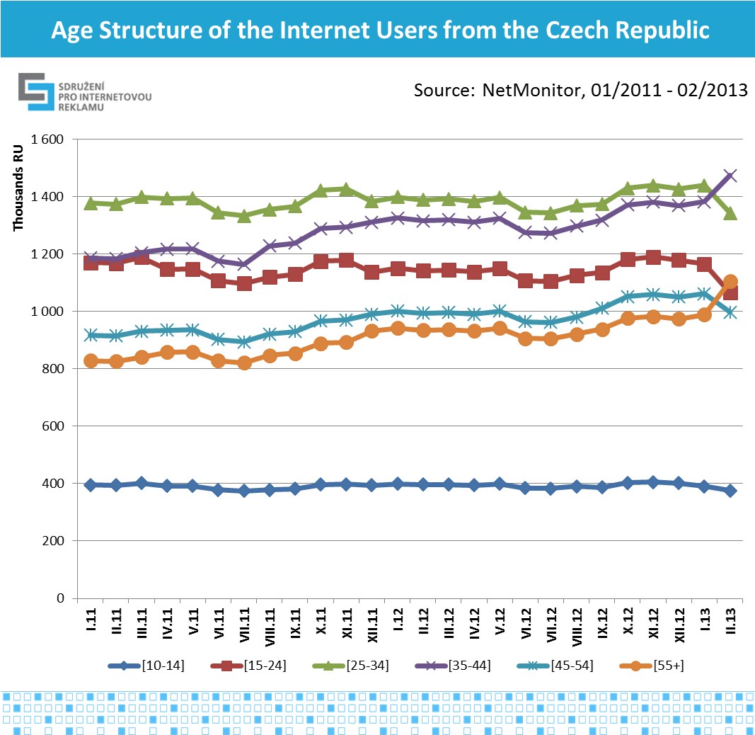

Graph No.14, source: NetMonitor – SPIR – Mediaresearch & Gemius, 1/2011-2/2013

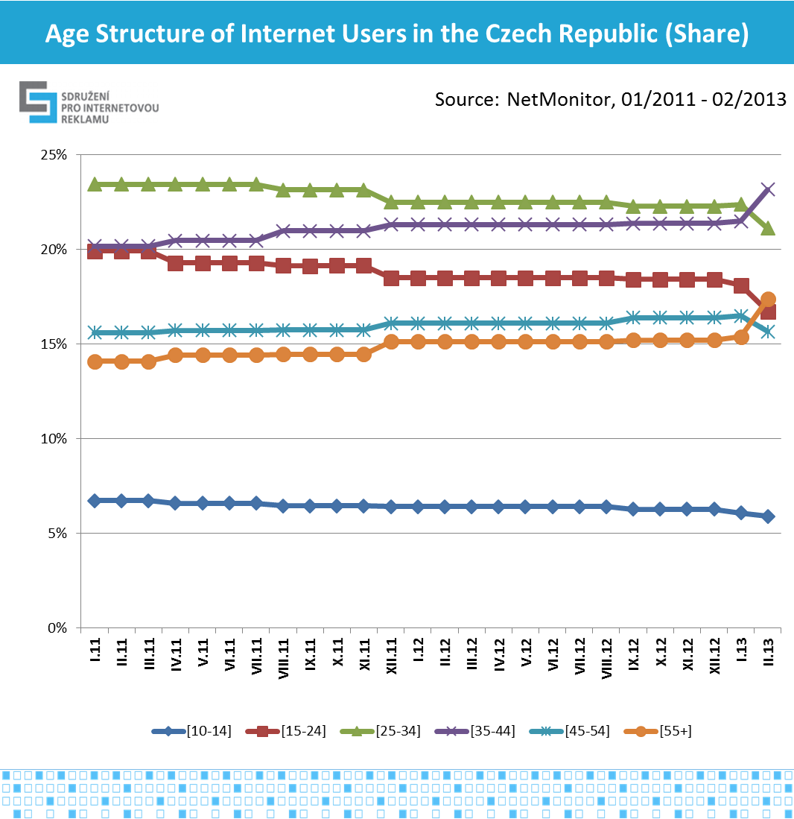

Graph No.15, source: NetMonitor – SPIR – Mediaresearch & Gemius, 1/2011-2/2013

Education of Internet Users

Graphs No.16 and No.17 show the trend in the education of Internet users is absolute numbers and percentual share. The most frequent education (highest completed) is secondary school with a diploma, with a 38% share (February 2013). In second place is secondary school without diploma (25 %), and after that are those with university education (15 %), followed by primary school education (8 %), unfinished primary school (8 %) and higher vocational education (6 %). The trend is an increase in the Internet population with a lower education level, particularly those without a diploma. Since the beginning of 2011 the share of university students is also slightly on the rise.

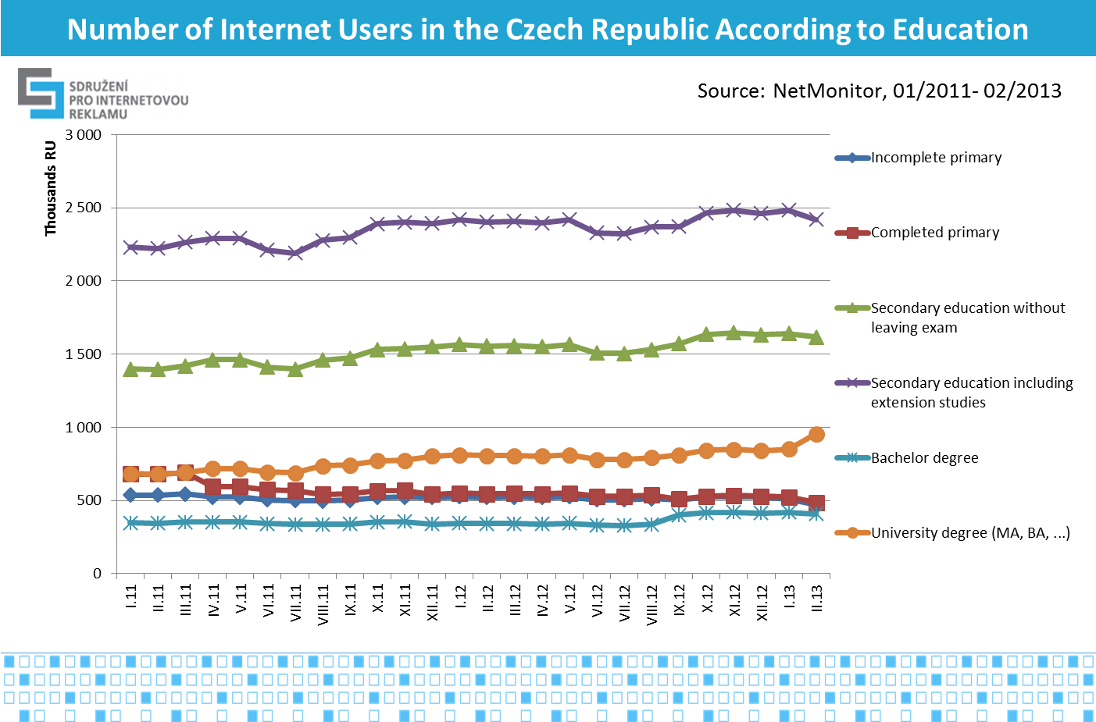

Graph No..16, source: NetMonitor – SPIR – Mediaresearch & Gemius, 1/2011-2/2013

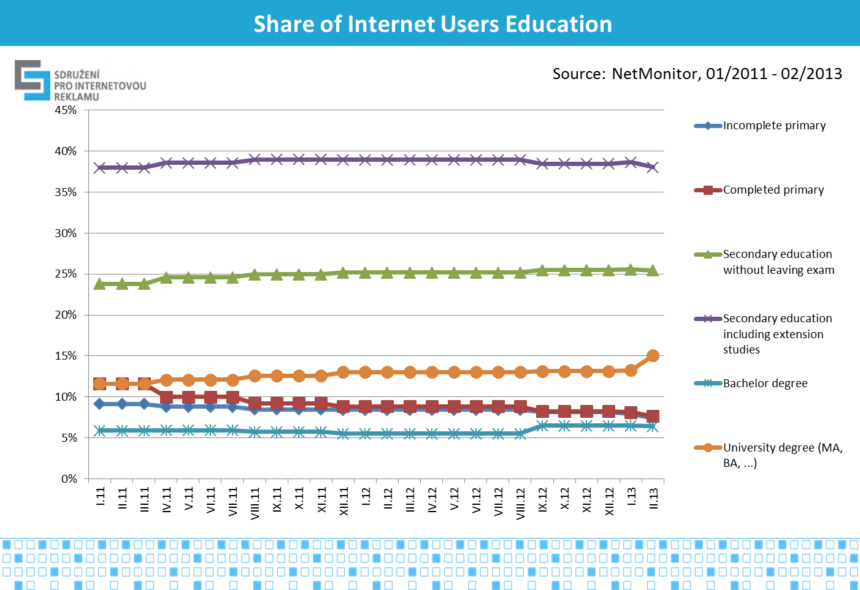

Graph No.17, source: NetMonitor – SPIR – Mediaresearch & Gemius, 1/2011-2/2013

ABCDE National Socio-economic Classification of Internet Users

Graphs No.18 and No.19 show the trend of the ABCDE national socio-economic classification (cumulative groups) of internet users in absolute numbers and in percentage share. The most represented classification is D+E, with a 48% share (February2013). Following it are groups C (29 %) and A+B (24 %). The share of individual groups tends to be in balance in the long term. An abrupt change in January 2012 was caused by the update of constants for the calculation of minimal cost of living, which are entered into the calculation of ABCDE classification. Constants are updated annually by the inflation rate.

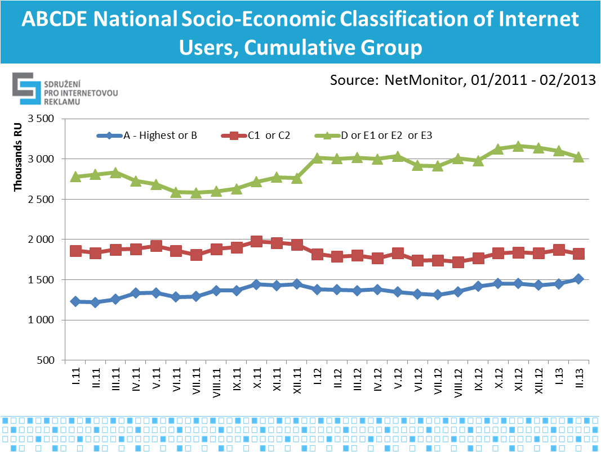

Graph No.18, source: NetMonitor – SPIR – Mediaresearch & Gemius, 1/2011-2/2013

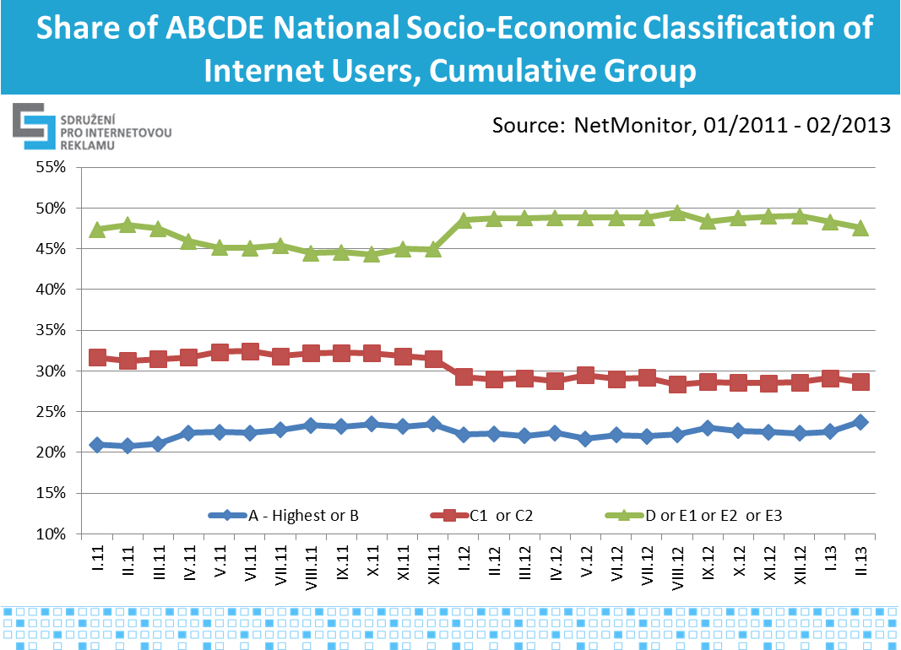

Graph No.19, source: NetMonitor – SPIR – Mediaresearch & Gemius, 1/2011-2/2013

ABCDE classification:

* A – Group with the highest social status in society, due to the high prestige of their occupation as well as the highest income.
* B – Group with above average income, usually upper management and group of senior professionals with at least secondary education.
* C1, C2 – Group with average living standard and average income. It is a group of those, for example, who are small business owners, technicians, clerks and lower professionals.
* D – Group with average or slightly below average living standard. This is a group, for example, of qualified manual workers.
* E1, E2, E3 – Group characterized by a below average living standard, in which are mostly found inactive individuals, i.e. unemployed, retired, or unskilled workers, etc.

Categories of Internet Media

The measurements of NetMonitor since the beginning of 2008 distinguish nineteen categories of Internet media. In February 2012, the structure was slightly changed, where the number of categories was expanded by another two categories - the categorization commission of SPIR divided in the interest of data transparency category No. 5, "Servers aimed at women, children, and health“ into three new categories:

* Category 5, "Magazines aimed at women and fashion" (created by renaming the original category),
* Category 20. "Health" and
* Category 21. "Pregnancy and Parenting".

Individual series of the categories cannot be tied together, so since February 2012 these were established.

Graphs No.20 and No 21 show the trend of the number of users in individual categories in absolute numbers. The category with the largest number of visitors are *home pages of directories* (February 2013) amounting to 5.7 million. RU (Czech Republic + Abroad), in second place are *Databases and Catalogs* (5 million RU); in third place is *News* (4.6 million RU). The fall in February 2013 was caused mainly by a shorter month (28 days). The decline in the category of *Communication Services* during 2012 and the subsequent jump in November 2012 was caused by the gradual transition of Seznam email users to a new version of the service. The new email of Seznam was measured by NetMonitor under a separate section and was added to the category of *Communication Services* since November 2012.

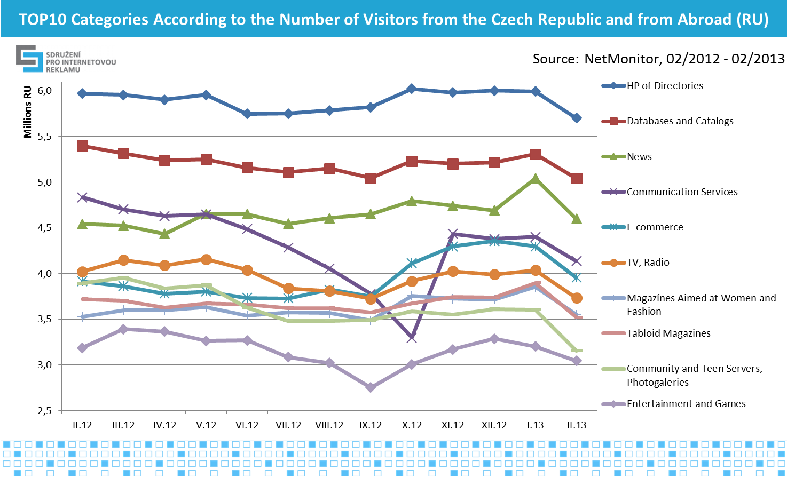

Graph No.20, source: NetMonitor – SPIR – Mediaresearch & Gemius, 2/2012-2/2013

The most viewed pages in February 2013 were from the category communication *services* (1.575 billion PV), followed by the *title pages of directories* (1.283 billion PV) and in third place was *e-commerce* (905 million PV).

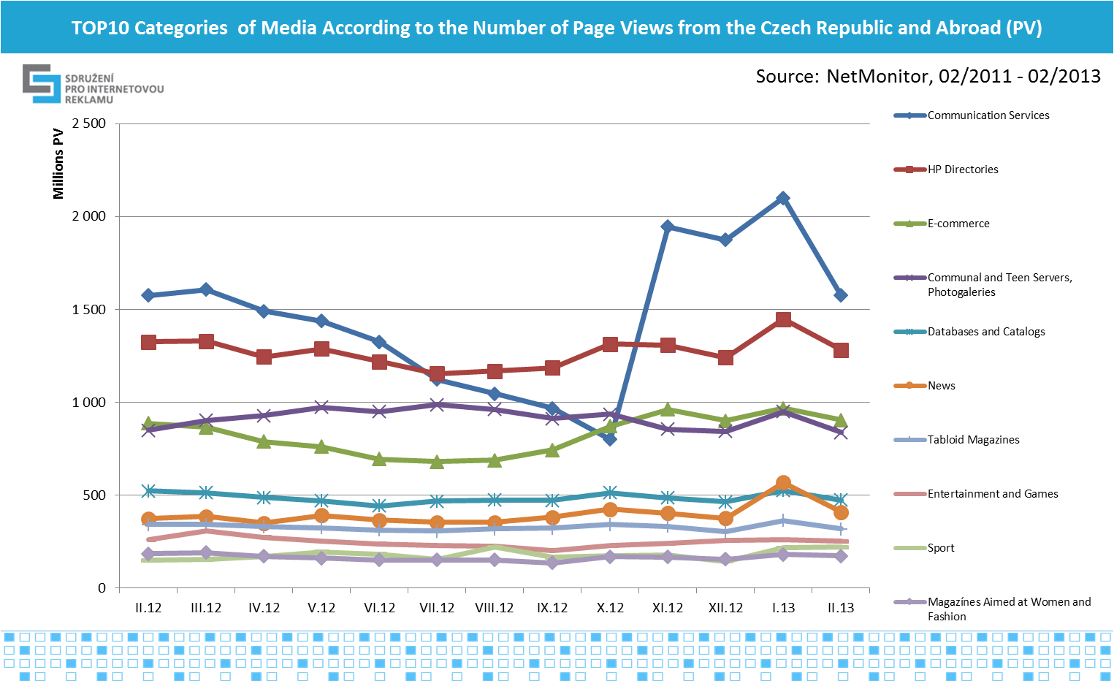

Graph No.21, source: NetMonitor – SPIR – Mediaresearch & Gemius, 2/2012-2/2013

Graph No.22 shows the trend of average monthly time spent per visitor in individual media categories. In first place in February 2013, with a time of 9 hours and 5 minutes per visitor is the category of title *pages of directories,* in second place with a time of 6 hours and 50 minutes is the category of *communication servers,* and in third place is the category i.e. *e-commerce* with the time of 2 hours and 28 minutes.

The ranking in the first three categories of measures is the same with the exception of RU, where *news*came before *communication services.*

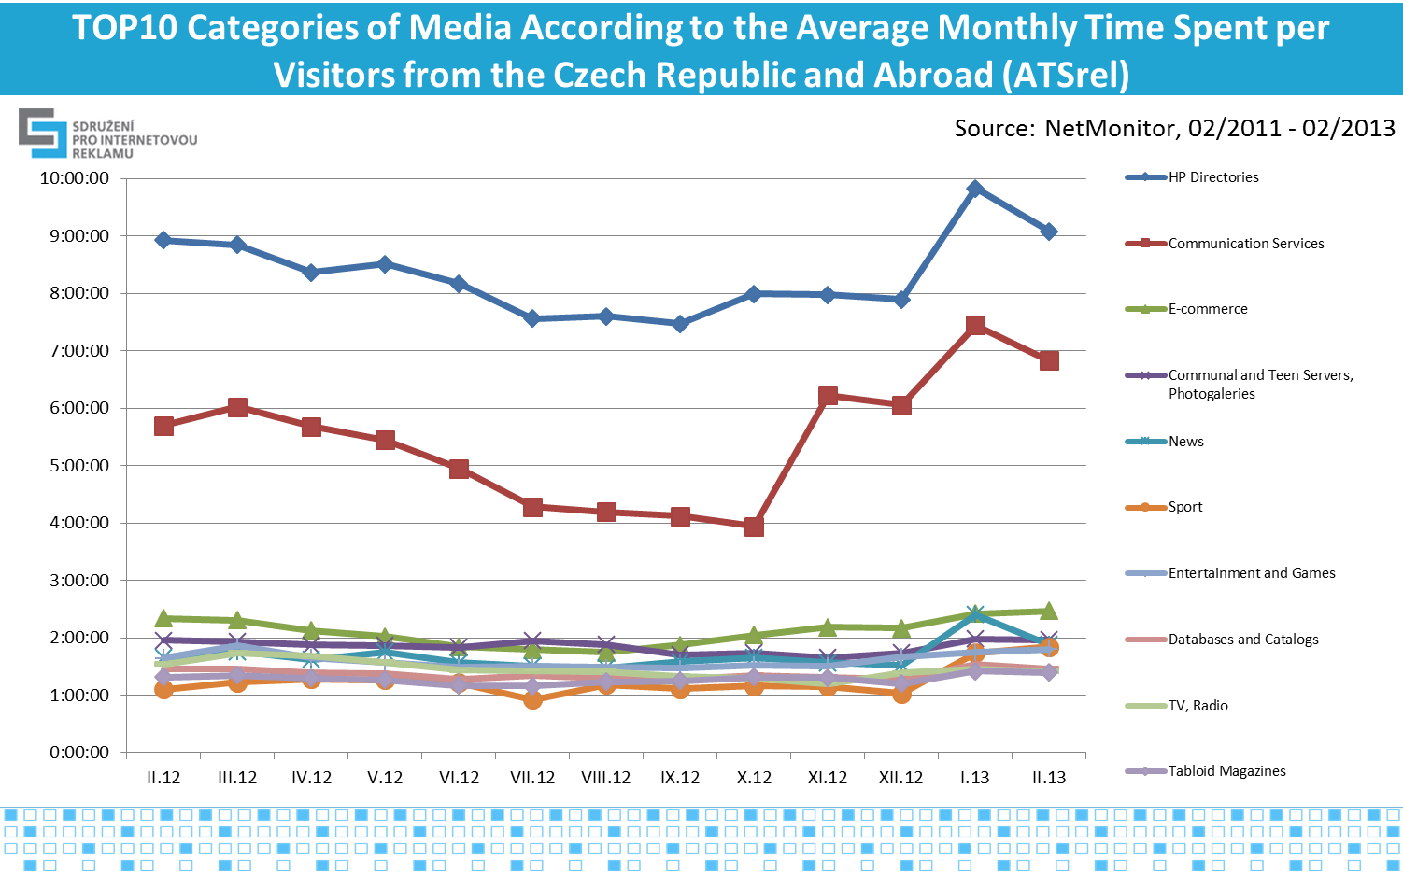

Graph No.22, source: NetMonitor – SPIR – Mediaresearch & Gemius, 2/2012-2/2013

Traffic from Mobile Devices

Since January 2013 are newly published results of Internet traffic from mobile devices. Measurement takes place on all common Internet pages and 30 mobile media involved in the research.

Overall, accessing to the Internet from mobile phones or tablets are 1.45 million users, who perform almost half billion page views, as graphs No 23 and No. 24 show. In comparison with the entire recorded traffic by NetMonitor, more than a fifth (22 %) Internet users use the Internet from mobile devices and 6 % of the traffic is from mobile devices as seen in graph No. 25. Penetration of Internet is 69 % and mobile Internet 15 % (based on 10+).

In February 2013, Czech users viewed 242 million pages on measured mobile media and 211 million pages on regular websites, a total of 453 million pages.

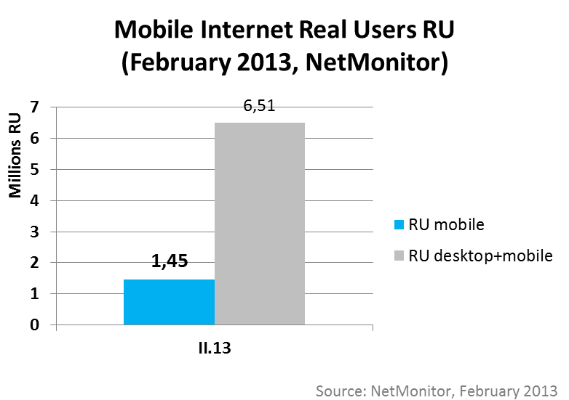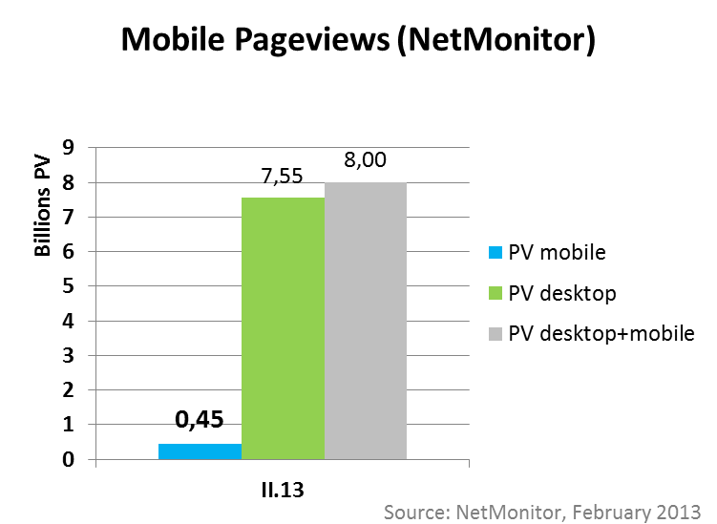

Graph No.23 and 24, source: NetMonitor – SPIR – Mediaresearch & Gemius, 2/2013; PV mobile = page views from mobile devices

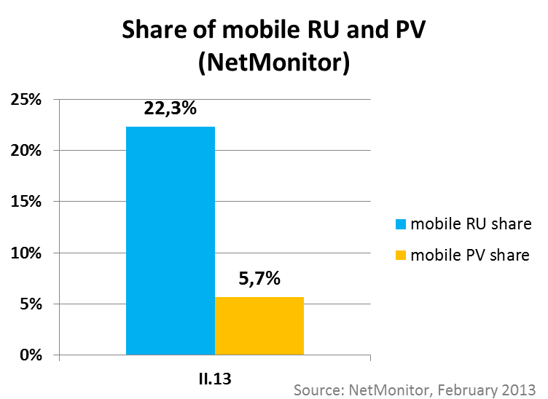

*Graph No.25, source: NetMonitor – SPIR – Mediaresearch & Gemius, 2/2013*

Stream Video Content Traffic

Since January 2013 is also newly available socio-demographic information about stream content traffic. In measurement of stream are so far involved 11 servers with total traffic (only video content) of 3 million unique viewers of video in the Czech Republic in February. The average viewed time for one viewer of stream is 2 hours and 43 minutes per month. In February 2013, these users viewed (started playing) 121 million videos, which means on average 41 videos per user. The average length of video ´viewing was 4 minutes. The following graph No.26 shows a comparison of the structure of web and stream visitors. Stream visitors compared to web site visitors are more numerously represented by the following groups:

* Men (52 % -> 56 %)
* Users 15-24 and older than 55
* Secondary school educated without a diploma
* Divorced
* Retired

Conversely, less represented are the following:

* Women (48 % -> 44 %)
* Users 35-44 of age
* University graduates

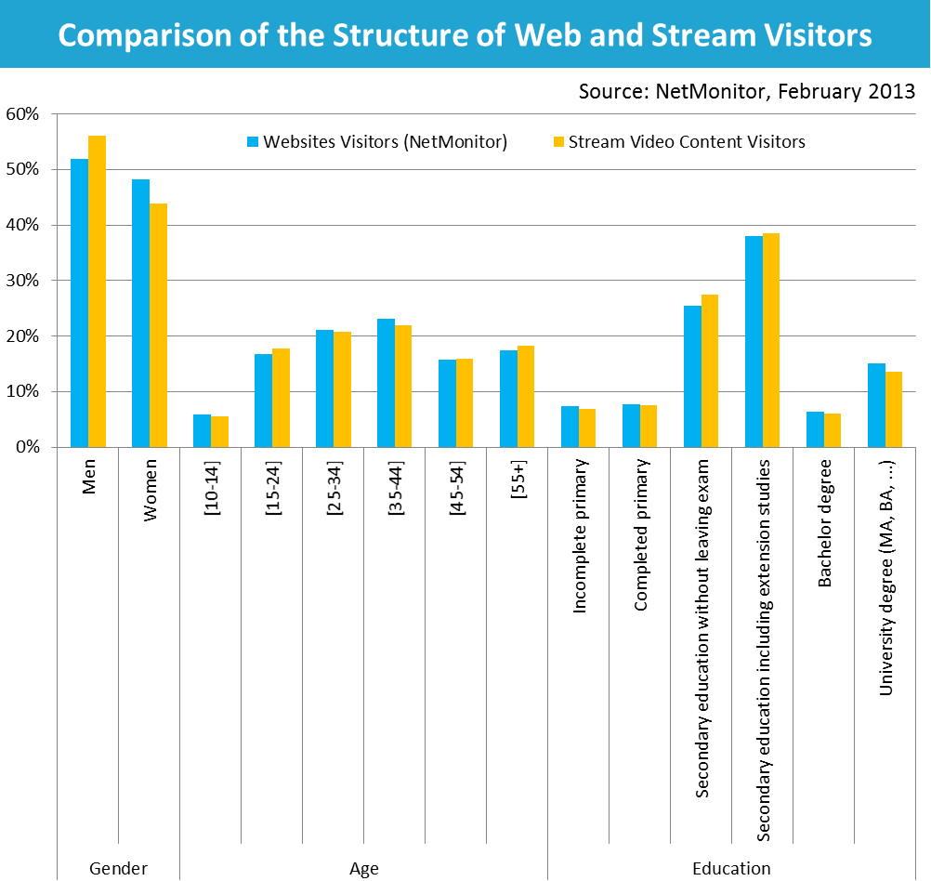

*Graph No.26, source: NetMonitor – SPIR – Mediaresearch & Gemius, 2/2013; only selected socio-demographic characteristics; visitors from the Czech Republic; the entire number of visitors (RU) is 6.36 million with web sites and 2.98 million with streams*

About the NetMonitor Project

NetMonitor (<http://www.netmonitor.cz>) is a very extensive research project, which aims to provide information about the Internet audience in the Czech Republic as well as the socio-demographic profile of the Internet visitors from the Czech Republic.

The sponsor of the project is SPIR (Sdružení pro internetovou reklamu, <http://www.spir.cz>). The implementer of the project is the Gemius S.A. Company, in cooperation with the MEDIARESEARCH, a. s. Company.

SPIR is a professional association working in the field of Internet advertising since the year 2000. Currently, the membership base of the association totals 60 members. Besides conducting unified, widely respected research of the traffic and the socio-demographic profile of Internet visitors by NetMonitor, it also conducts a project of monitoring Internet advertising AdMonitoring, analyses of Internet advertising campaigns through AdAudit, professional conference about Internet marketing IAC, provides expert analyses of the Internet market trend in the country, and is a self-regulator of audiovisual content. The newest SPIR project is AdAudit, a tool for analyzing the impact of on-line marketing campaigns, which is in operation since September 2012.

Petr Kolář, SPIR Analyst, [petr.kolar@spir.cz](mailto:petr.kolar@spir.cz), 21.4.2013