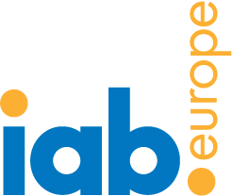 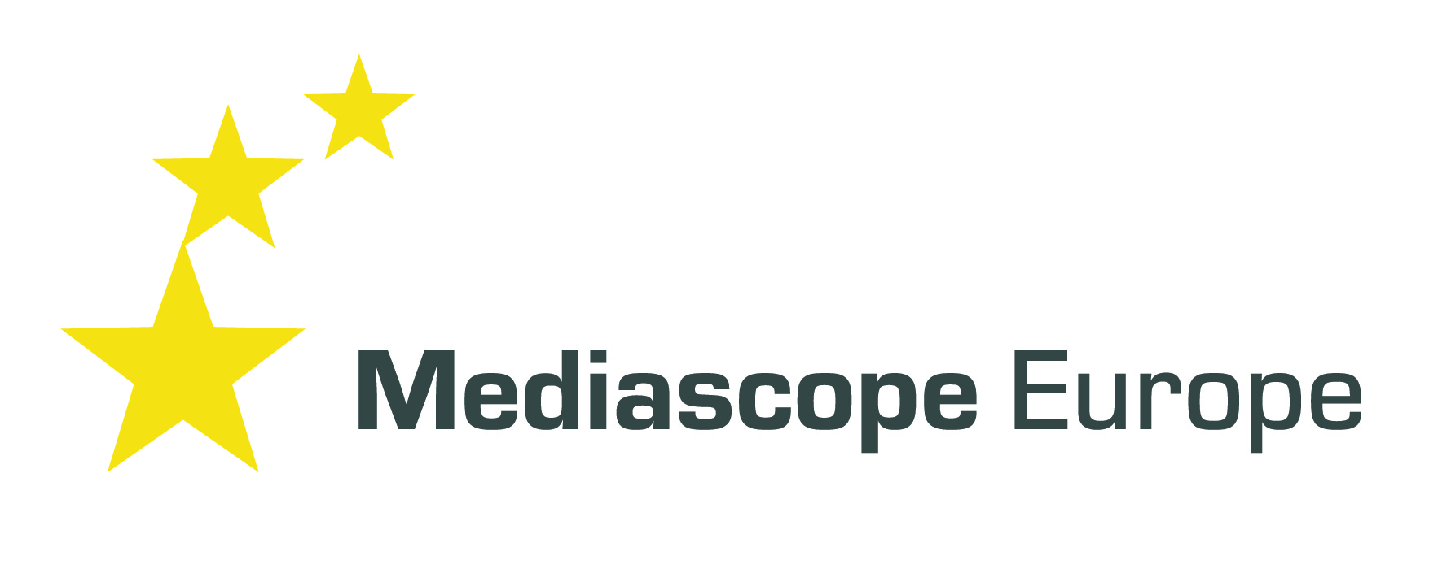

**IAB Europe expands Mediascope Europe study to cover 28 markets in 2012**

**London 28th February 2012:** The Interactive Advertising Bureau Europe (IAB Europe) is pleased to announce the expansion of Mediascope Europe, the industry standard European media consumption study. In 2012 the study will include a further 13 markets incorporating Austria, Bulgaria, Croatia, Czech Republic, Finland, Greece, Hungary, Ireland, Romania, Serbia, Slovakia, Slovenia and Ukraine in addition to the original 15 markets already covered by the research – Belgium, Denmark, France, Germany, Italy, Netherlands, Norway, Poland, Portugal, Russia, Spain, Sweden, Switzerland, Turkey and UK. The research aims to capture the different ways in which consumers are developing across Europe and assess their similarities and differences.

The findings from the Mediascope Europe study will be launched at Interact 2012, the definitive event for the European online advertising industry, taking place on 30th and 31st May.

Mediascope Europe is unique in identifying changing media consumption patterns at total population level in online, radio, TV, mobile, newspapers and magazines and doing a deep dive into digital media consumption and e-commerce – all across multiple markets. The study includes the evolution of media multi-tasking and emerging and evolving online media including internet use via mobiles, tablets and game consoles. Video consumption, social media and e-commerce are investigated in depth to give a rounded picture of the interactive consumer. An Omnibus + Online methodology will be used across all countries totaling over 50,000 interviews. Mediascope Europe is widely recognised as the industry standard consumer research study on the European media landscape and includes historical data back to 2003.

IAB Europe aims to make the Mediascope Europe data available via several planning tools allowing users to mine and manipulate the data by country, demographic or media user. First to be available is Nielsen IMS Clear Decisions™ through an IAB Europe subscription service*.

Alison Fennah, Vice President of Research and Marketing says “Mediascope Europe is the most comprehensive media consumption study covering the diverse European market. With this expansion it becomes a flagship product and reference point for the IAB European network and will be increasingly sought out by marketers and businesses to understand the latest media trends and inform and shape their strategies.”

**Ends**

**Mediascope Europe Sponsors:**

Mediascope Europe 2012 is supported by many leading media companies, local IABs and other trade associations.

Pan-European sponsors:

Microsoft Europe, Orange Advertising Network, Yahoo! Europe, BBC Advertising, Adconion Media Group, United Internet Media, AOL Advertising Europe, Viacom International Media Networks

Local sponsors by market:

Austria – IAB Austria; Goldbach, httpool, Laola1.at, Mediacom, Microsoft, Mindshare, Mindtake, ORF, ÖWA, United Internet Media

Belgium: IAB Belgium

Bulgaria – IAB Bulgaria; 3bay.bg, Darik Web, Dir.bg, Economedia, Investor, Mail.BG, MTel, Netinfo, NEG, Thinkdigital

Croatia – INAMA; ad-net, Mastercard, unex MPG, Xclaim

Czech Republic – Sdružení pro internetovou reklamu (SPIR)

Denmark – Foreningen af Danske Interaktive Medier (FDIM)

Finland – IAB Finland

France – IAB France

Germany – IAB Germany (OVK)

Greece – IAB Hellas; 24 Media, Atcom Internet & Multimedia, MSN.gr, Reprise Media, Tempo OMD Hellas, Yahoo! Greece

Hungary – IAB Hungary; Gemius Hungary, Google, Kirowski Isobar, MEC Interaction, OMG Hungary, Origo, Ringier, Sanoma, Schibsted, Thinkdigital

Ireland - IAB Ireland; ADTECH

Italy – IAB Italy

Poland – IAB Polska

Portugal – Associação Comércio Electrónico e Publicidade Interactiva (ACEPI)

Romania – IAB Romania; Google Romania, Httpool Online and Mobile Advertising, Initiative Media, Leo Burnett, Media Investment, P&G, Think Digital, Vodafone

Russia – IAB Russia; Google Russia, Video International, Yandex

Serbia – IAB Serbia; Direct Media, Executive Group, Fastbridge, Huge Media, Infostud Group, Kreativa New Formula, Media House, Media S SMVG, nadlanu.com, One Media (ZenithOptimedia), Ringier Axel Springer, sportal.rs

Slovakia – IAB Slovakia

Slovenia – Delo, Futura Group, Goldbach Audience, Google, Grey ljubljana, Httpool, Interactive.agency, Iprom, Media Publikum, Pristop Media, SONCE.NET, Telekom Slovenije d.d., TSmedia, ZenithOptimedia

Spain – IAB Spain

Switzerland – IAB Switzerland

Turkey – Yandex

Ukraine – Google Ukraine, Ukrainian MediaHolding, Yandex

United Kingdom – IAB UK

The study is produced with the support of members and non-members of IAB Europe and in the case of non-members this does not imply any relationship with IAB Europe other than that of Mediascope Europe sponsor.

**Mediascope Europe Suppliers:**

The lead market research agency for Mediascope Europe since 2005 is SPA Future Thinking, based in London. The omnibus fieldwork is conducted by Amarach, DataCollect, Doxa, Epinion, Focus Bari, FOM, Gallup, GfK, I’m Research, IMAS International, Ipsos, ISOPUBLIC, Mediaresearch, Prizma, Romir, Simple Logica, TNS and Yontem; the online part of the study is conducted by QuestBack in cooperation with Annik, DataCollect, Focus Bari, Gemius, GMI, Mediaresearch and MindTake.

**Note to editors:**

* Fee applies and access to number of markets and depth of trend data depends on subscription level

**Media please contact:**Lucy Green, PR Consultant (English) Tel: +44 (0) 7817 698366

[publicrelations@iabeurope.eu](mailto:publicrelations@iabeurope.eu); lgreen@greenfieldscommunciations.com

Geraldine Gitel, PR Consultant (French/English) Tel: +44 (0) 7917 885380/00 33 6772 5050

[publicrelations@iabeurope.eu](mailto:publicrelations@iabeurope.eu); [ggitel@greenfieldscommunications.com](mailto:ggitel@greenfieldscommunications.com)

**For more information about Mediascope, please contact:**

Sarah Botterill, Insight and Communications Manager [insight@iabeurope.eu](mailto:insight@iabeurope.eu)

Alison Fennah, VP Research and Marketing [vprm@iabeurope.eu](mailto:vprm@iabeurope.eu)

**About IAB Europe**

IAB Europe is a federation of national Interactive Advertising Bureaux (IAB) across Europe. Its mission is to promote the growth of the interactive advertising markets on behalf of its clients and national members. Supported by every major media group, advertisers, agency, portal, technology and service provider, its voice represents the interest of more than 5500 company members. IAB Europe coordinates activities across the region including public affairs, benchmarking, research, setting standards and best practices. The member countries are Austria, Belgium, Bulgaria, Croatia, Czech Republic, Denmark, Finland, France, Germany, Greece, Hungary, Ireland, Italy, Netherlands, Norway, Poland, Romania, Russia, Serbia, Slovakia, Slovenia, Spain, Sweden, Switzerland, Turkey, Ukraine and United Kingdom. Our corporate members include Adconion Media Group, Adobe, ADTECH, Advance International Media, Alcatel-Lucent, AOL Advertising Europe, AudienceScience, Banner, BBC Advertising, CNN, comScore Europe, CPX Interactive, Criteo, eBay International Advertising, Emediate, Expedia Inc, Fox Interactive Media, Gemius, Goldbach Media Group, Google, GroupM, Hi-Media, Koan, Microsoft Europe, Millward Brown, News Corporation, NextPerformance, nugg.ad, Nielsen Online, OMD, Orange Advertising Network, PHD, Prisa, Publicitas Europe, Quisma, Right Media, Sanoma Digital, Selligent, TradeDoubler, Tribal Fusion, Triton Digital, Turn Europe, United Internet Media, ValueClick, Verisign, Viacom International Media Networks, White & Case, Yahoo! and zanox. [www.iabeurope.eu](http://www.iabeurope.eu)