## Press Release

**The year 2020, marked by online life, brought growing advertising costs: 40 billion CZK**

*Prague, 15 March 2021 –* **As our life and work have switched to the online environment, the cost of Internet advertising went up, reaching almost 40 billion CZK in 2020. Compared to 2019, this represents a 15% increase, to which display advertising (+ 12%) and search engine advertising (+ 25%) contributed in absolute values the most. In terms of the way of advertising space trading, the programmatic display advertising purchases went up by 8%. Despite the current situation with the Covid-19 pandemic, forecasts for the next year remain optimistic. Survey participants expect online advertising to grow by 8% in 2021. Online advertising accounts for more than 30% of total advertising costs across all media types, putting it in second place right after television advertising since 2016. The data come from an Internet advertising performance survey conducted for  Association for Internet Progress (SPIR) by the Median Agency. The data concerning other media types were provided by Nielsen-Admosphere.**

# Trend in the total cost of Internet advertising

**In 2020, advertisers used Internet advertising amounting to 39.5 billion CZK.[[1]](#footnote-1) It is the highest investment so far, representing a 15% increase as compared to the previous year** and confirming the ever-increasing trend in the use of online forms of advertising. This year's increase is estimated at 8%, which would represent a total investment of 42.5 billion CZK in Internet advertising in 2021. *"Last year was exceptional in many respects, but in my opinion the switch of most activities to the online environment due to various anti-epidemic measures is crucial. This also corresponds to the increase in advertising investments because advertisers logically try to reach customers where they spend the most time. The survey of Internet advertising performance combines net prices with list prices and so this is why I believe that online advertising performance is in fact much stronger as compared to the actual performance of other media types than it may seem. The volume of Internet advertising approaches real investments in television advertising. The reason is that other media types work exclusively with list prices,”* Michal Hanák, Chair of the SPIR Executive Board, commented on the survey results.

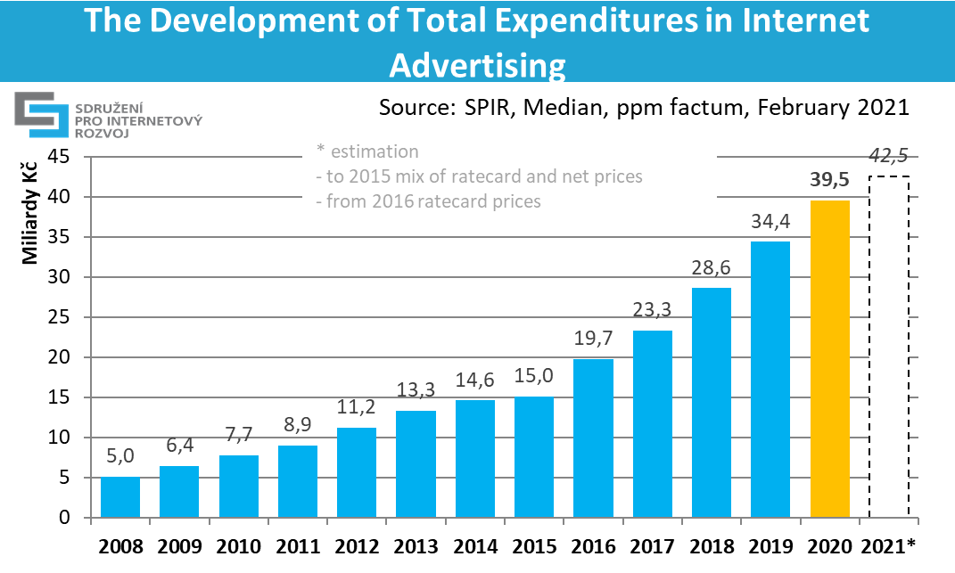

*chart 1: The Development of Total Expenditures in Internet Advertising*

**The largest part of advertising expenditures is attributable to display advertising (CZK 27,0 billion in ratecard prices).** Display advertising includes also advertising in content networks (in particular Seznam Sklik, Google Ads and Facebook), and RTB. **The second most frequently used advertising form is paid search with expenditures of CZK 11,3 billion in real prices**. The sales in respect of classifieds and directories were declared in the amount of CZK 1,2 billion in ratecard prices.

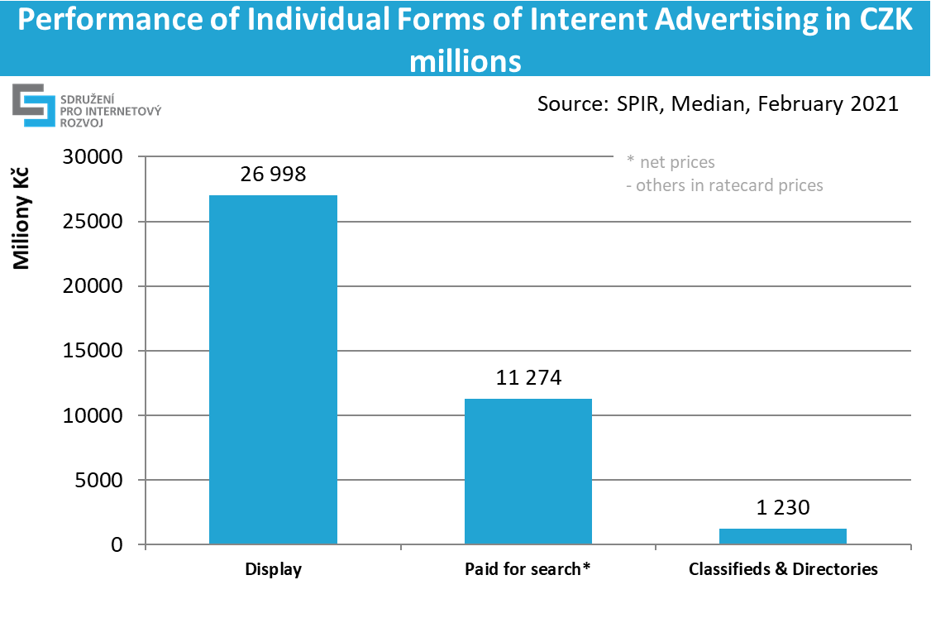

*chart 2: Market share of Individual Internet Advertising Forms in 2020*

**Video advertising represented a 29 per cent share of the overall display advertising (CZK 7,7 billion),** i.e. a 11 per cent year-to-year increase, and is expected to grow by 9 per cent in 2021. **Native advertising had a 12 per cent share (CZK 3,11 billion),** i.e. a 16 per cent year-to-year increase, and is expected to grow by 9 per cent in 2021.

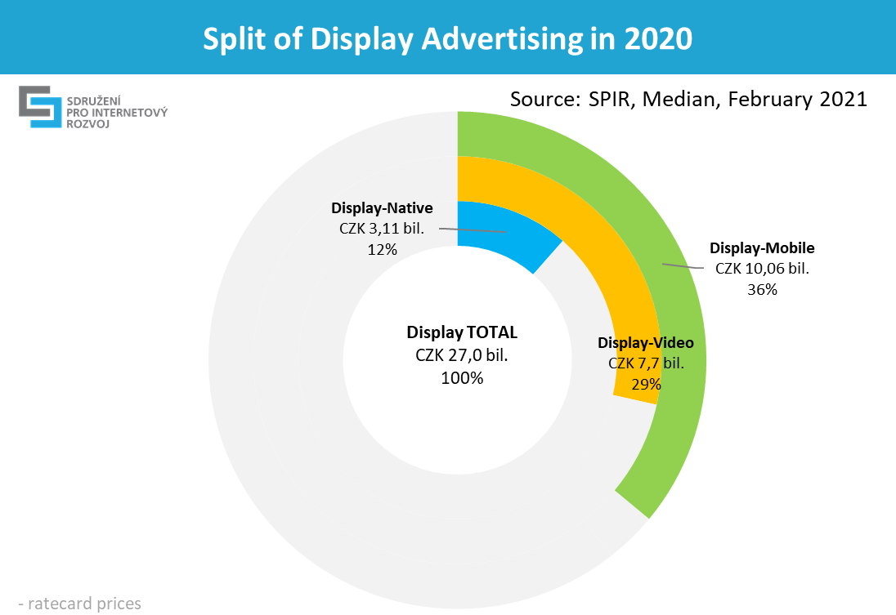

*chart 3: Split of Display Advertising in 2020*

**The share of mobile advertising out of the overall display advertising was 36 per cent (CZK 10,1 billion**)**,** i.e. a 22 per cent year-to-year increase, and is expected to grow by 10 per cent in 2021.

**Programmatic forms of advertising, which is related to content networks and RTB, together represented a 62 per cent share (CZK 16,9 billion in ratecard prices)** and increased by 8 per cent, if compared to the last year. The estimate for this year is growth of 10%.

Programmatic displays include the advertising performance of content networks (such as Seznam Sklik, Google Ads, Facebook, Instagram, and more) as well as the performance of advertising through DSP / SSP systems.

**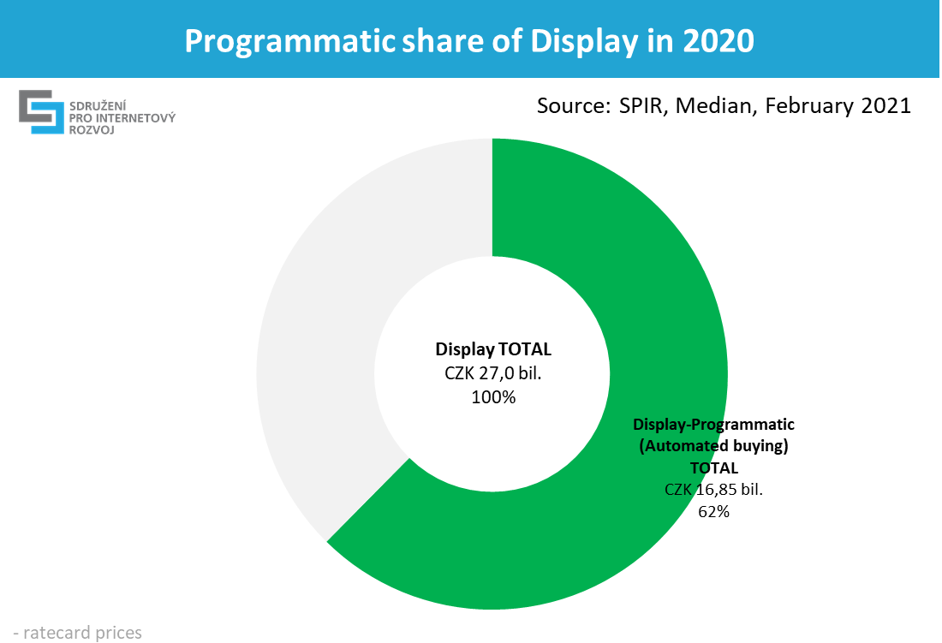**

*chart 4: Breakdown of display advertising according to the purchase form in 2020*

# Development of Individual Forms of Internet Advertising

**The long-term growth is clearly visible in the case of display and search advertising**. With display advertising, all its parts are growing, but most of them have been growing part of mobile display advertising, which is a logical consequence of the growing penetration of mobile devices and the activity of their users.

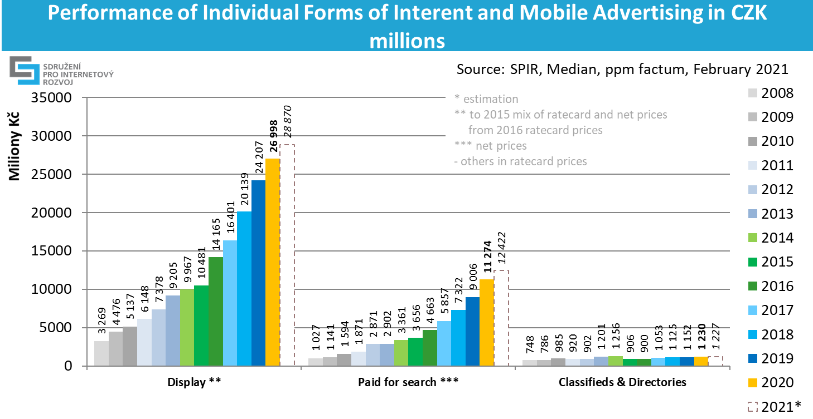

*chart 5: Performance of individual forms of internet advertising*

**Performance of individual forms of internet advertising in CZK ths.:**

|  |  |  |  |  |  |  |  |  |  |  |
| --- | --- | --- | --- | --- | --- | --- | --- | --- | --- | --- |
| **in thousands of CZK** | **2012** | **2013** | **2014** | **2015** | **2016** | **2017** | **2018** | **2019** | **2020** | **2021\* (estimate)** |
| **Display \*\*** | 7 378 185 | 9 204 844 | 9 967 379 | 10 481 447 | 14 164 675 | 16 400 893 | 20 139 248 | 24 207 282 | 26 998 476 | 28 869 710 |
| **Paid for search \*\*\*** | 2 871 428 | 2 901 804 | 3 360 886 | 3 656 319 | 4 663 124 | 5 857 274 | 7 321 593 | 9 005 559 | 11 273 892 | 12 421 574 |
| **Classifieds & Directories** | 901 784 | 1 200 788 | 1 256 196 | 906 356 | 899 652 | 1 052 715 | 1 124 984 | 1 152 238 | 1 230 314 | 1 226 692 |
| **TOTAL \*\*** | **11 151 399** | **13 307 435** | **14 584 460** | **15 044 122** | **19 727 451** | **23 310 883** | **28 585 825** | **34 365 080** | **39 502 681** | **42 517 977** |

*\* estimate  
\*\* ratecard and real prices mix until 2015, ratecard prices since 2016   
\*\*\* real prices (net net)  
the rest in ratecard prices (gross)*

*table 1: Performance of individual forms of internet advertising in CZK ths.*

**Share of Individual Mediatypes in 2020**

For the purpose of comparing the volume of advertising in individual media types, data derived from the Nielsen Admosphere monitoring of advertising expenditures were used. **TV advertising with CZK 62,2 billion maintains its dominant position in the advertising market (47,6 per cent). Online advertising has a 30,3 per cent share (CZK 39,5 billion).** Press advertising reached CZK 17,2 billion and has an 13,2 per cent share in advertisement budgets. Radio advertising reached the level of CZK 7,3 billion (5,6 per cent) and OOH advertising generated CZK 4,4 billion (3,4 per cent) last year.

The prices do not include self-promotion.

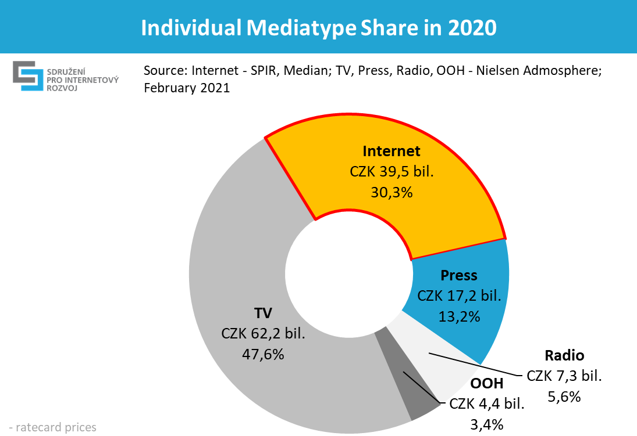

*chart 6: Individual Mediatype Share in 2020*

The comparison of the Internet with other media types should be regarded in terms of trend rather than absolute performance because price comparisons are not accurate. The surveys of other media types use list prices that do not exist in the majority of online advertising forms. Only less than 30% of the mentioned Internet performance is shown in list prices (direct display). Another 29% are shown in unchanged real net net prices (search) and only the rest (programmatic display) uses at least an additional + 15%. The Internet as such is gradually converging toward real prices only. The difference between list prices and real prices used by other media types is growing especially during the covid-19 pandemic, which is why comparisons of different media types are becoming less and less relevant.

The full version of the internet advertising performance is to be found at: <http://www.inzertnivykony.cz/en>.

The used types of internet advertising are to be found at: <http://www.inzertnivykony.cz/en/terminology-methodology>.

More detailed description of advertising forms are to be found at: <http://www.spir.cz/reklamni-formaty-a-html-5>.

Below you will find selected terms that might be incorrectly understood from the viewpoint of terminology. A more detailed version is to be found at the above specified links.

**Internet display advertising:** Banner advertising in standard (banners, skyscrapers, leaderboards...) and non-standard formats (overlays, interstitials) and video banners. Now the display advertising also includes content network and RTB.

**Paid search advertising:** Advertising appearing on specific word requests on search engines or premium positions.

**Programmatic:** automated process of purchase and sale of digital advertising space. Display programmatic includes content network and RTB.

**RTB (real-time-bidding)** is a type of business model for selling banner advertising targeted at desired audience, where each impression is delivered in real time by automatic systems as is appropriate for the required target group. In the RTB model, geographical, linguistic or behavioural targeting of advertising is often used, on the basis of previous activity and the interests of the user. The main characteristic of the RTB model is the auction sale in real prices of advertising. Now RTB advertising is included within display advertising.

# Methodology Description

For the purpose of surveying and processing the results, in the interest of objectivity and the protection of sensitive data, the Median agency was commissioned. The survey was conducted during January and February 2020 and was based on current closings of individual subjects. The performance of all types of advertising was based on declared performance of individual providers of content, agencies, and operators of advertising networks and mobile operators.

From 56 important internet publishers, who were addressed, 22 became actively involved; their media have impact on vast majority of Czech Internet users. In order to obtain data on the performance of individual advertising networks, three operators, 46 media, digital and specialized agencies, as well as 163 direct advertisers were addressed. One operator of an advertising network (Sklik of Seznam.cz), 19 agencies and 7 direct advertisers undertook active participation. To calculate the total advertised amount in advertising networks, the claimed performance of the Sklik advertising network is used; along with the weighted average of the percentage distribution of spending by agencies into advertising networks. Due to the historical absence of DSP system operators, DSP systems were not asked this year. Therefore, the performance of programmatic display advertising through DSP / SSP systems cannot be calculated on the whole market. For data consistency, the following corrections were made:

* Adjustment of the division of the performance of advertising networks into search and display advertising: The performance of search advertising was adjusted to the size from 2019, increased by the observed trend 2020/2019. The display part of advertising networks was created by adding to the unchanged unit of advertising networks.
* The size of advertising through DSP / SSP systems (RTB advertising) was determined by the size from 2019, increased by last year's trend estimate for 2020/2019.
* The sizes of display video and native advertising were determined by the sizes from 2019, increased by last year's trend estimates for 2020/2019.

This year, search ad performance was adjusted based on an expert SPIR estimate. The size of advertising through DSP / SSP systems (RTB advertising) was determined by the size of 2018 (the sum of declared absolute performances from agencies and direct advertisers), promoted by the 2019/2018 trend of this advertising from the media side.

Data up to 2016 include partial correction of prices in the case of those internet display advertising, which are obtained in real (net net) prices, because they have no ratecard prices.

For the purpose of comparison with the volume of other advertising, which is indicated in ratecard prices, as well as other media types, the prices of programmatic forms (content networks and RTB) were increased by 15 per cent. The difference between a ratecard and real price is, undoubtedly, higher but because of insufficient support the minimal value was finally used.

For the purpose of transparency, volumes of programmatic forms of display advertising are indicated in real (net net) prices. Search advertising remains in real prices, and since it is not display advertising, the subsequent calculation is not necessary. The remaining media types use ratecard prices; estimates of real prices are not available.

Description of forms of the internet display advertising is to be found [here](http://www.spir.cz/reklamni-formaty-a-html-5" \t "_blank).

**For more details, please, contact:**

**Peter Kokavec** – technical inquiries

SPIR Project Manager

mobile: 775 200 949

e-mail: [peter.kokavec@spir.cz](mailto:peter.kokavec@spir.cz)

**Petr Kolář** – technical inquiries

Analyst

mobile: 603 749 847

e-mail: [petr.kolar@spir.cz](mailto:petr.kolar@spir.cz)

**Tereza Tůmová** – other inquiries

PR Manager

mobile: 739 465 233

e-mail: [tereza.tumova@spir.cz](mailto:tereza.tumova@spir.cz)

1. In list prices. For more information, see the methodology at the end of the press release. [↑](#footnote-ref-1)