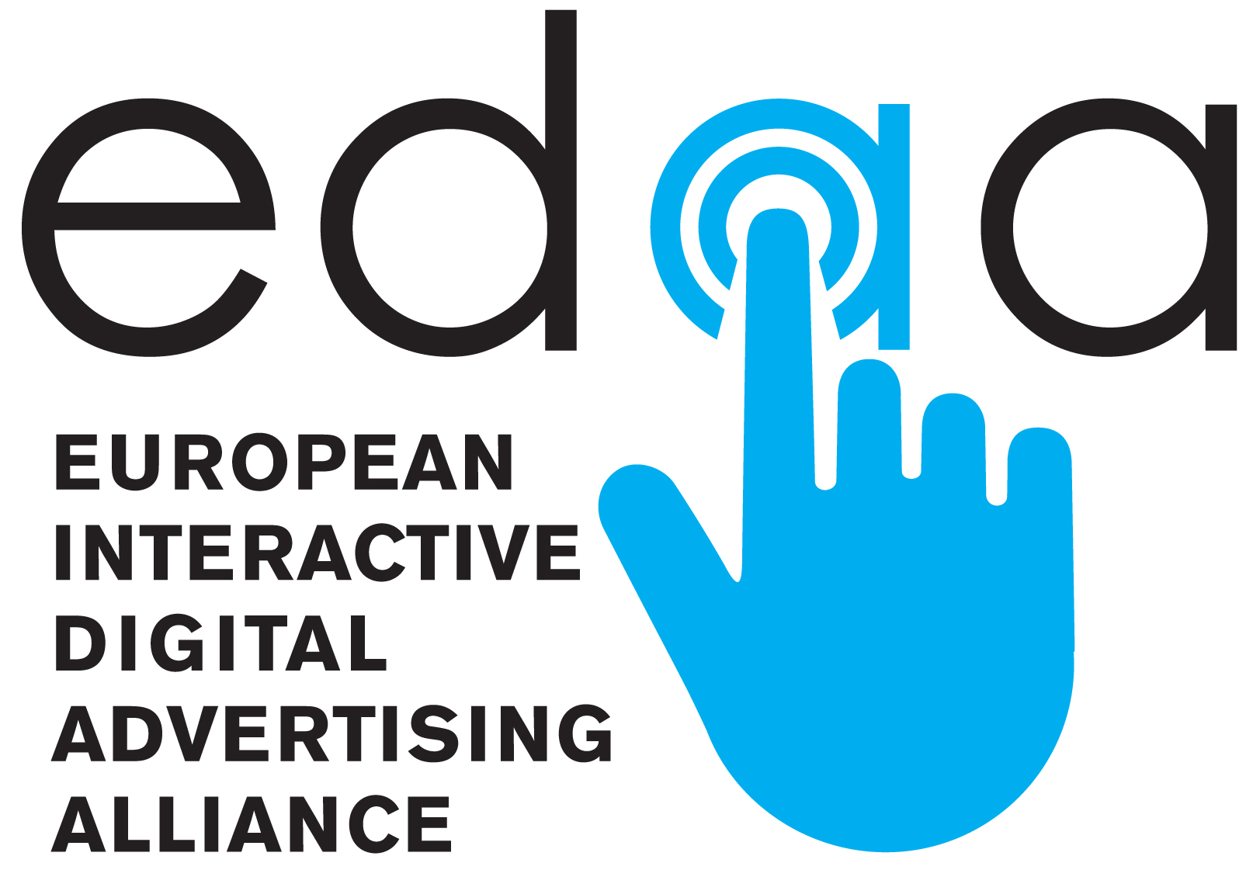

News Release

For release 12.10.12

EUROPEAN INTERACTIVE DIGITAL ADVERTISING ALLIANCE LAUNCHED
- New EU body created to administer aspects of self-regulatory programme for online behavioural advertising across Europe – www.edaa.eu
- Icon at the heart of an EU initiative to give internet users transparency, choice and control over online behavioural advertising – www.youronlinechoices.eu

Brussels, 12 October 2012: - Key stakeholders from the European digital advertising community met today to officially launch the European Interactive Digital Advertising Alliance (EDAA). As of today the EDAA will be responsible for administering the licensing of an interactive icon to businesses operating across Europe and websites involved in the delivery of online behavioural advertising (OBA), where ads are customised to users’ likely interests based upon the various websites they have previously visited.
Companies are rolling-out the icon in or around online ads and on websites as part of a pan-European initiative aimed at providing internet users with transparency, choice and control over online behavioural advertising. The icon, when clicked on, provides internet users with clear information about the data collected and used for online behavioural advertising and how it can be managed and controlled by the internet user. This includes linking to a ‘one stop shop’ website, www.youronlinechoices.eu, now available in 24 different languages, where internet users can find more information. The initiative joins up with a similar initiative in the USA, providing global consistency for consumers and businesses.
Speaking at today’s launch, Robert Madelin, Director General for Communications Networks, Content and Technology at the European Commission said “I am impressed with the way in which the advertising industry has succeeded, in a short time, in putting in place a new, effective self-regulatory framework. The principles, procedures and tools help to manage online behavioural advertising and to raise citizens’ awareness. Together, these efforts will contribute significantly to empowering internet users in the management of their privacy across Europe. The launch of EDAA today actively demonstrates this progress and the Commission will be following uptake closely.”
As part of the EU programme, companies will be held accountable for their implementation of the initiative. A new EDAA ‘trust seal’ will be issued to companies that have proven their compliance with the initiative through an independent certification process. In addition to this, internet users will be able to raise concerns about a company’s OBA practices with their national advertising self-regulatory organisation. These complaint handling bodies will then investigate issues raised and take action where appropriate, based on a consistent European approach.
The EDAA is planning a complementary pan-European education campaign for early 2013 aimed at increasing awareness of the icon, informing European citizens about what online advertising is and helps to fund and to help explain how consumers can manage their privacy preferences.

“Companies are committed to the European self-regulatory approach in order to create a trusted online environment where consumers can feel confident that their privacy interests are fully accounted for”, highlighted Alain Heureux, Chairman of the EDAA.

--------------End--------------
Press contact
Ionel Naftanaila – Project Manager EDAA, or Dave Barron – Project Officer EDAA
Tel: +32 (0)2 513 7806 | info@edaa.eu

Notes to editors

About the EDAA
The European Interactive Digital Advertising Alliance (EDAA) is a non-profit organisation based in Brussels and is responsible for enacting key aspects of the self-regulatory initiative for online behavioural advertising (OBA) across Europe. EDAA principally acts as the central licensing body for the OBA icon and provides technical means for consumers to exercise transparency and control over OBA through the User Choice platform on www.youronlinechoices.eu.

EDAA is governed by EU-level organisations which make up the value chain of OBA within Europe and acts to ensure consistency in the European self-regulatory approach. The EDAA’s guiding principles are laid out in the Interactive Advertising Bureau Europe (IAB Europe) OBA Framework and the Best Practice Recommendation for Online Behavioural Advertising of the European Advertising Standards Alliance (EASA).

The following organisations are governing bodies of the EDAA: Association of Commercial Television in Europe (ACT), Association of European Radios (AER), Europe Analytica (EA), European Association of Communications Agencies (EACA), Association of Television and Radio Sales Houses (EGTA), European Magazine Media Association (EMMA), European Newspaper Publishers Association (ENPA), Federation of European Direct and Interactive Marketing (FEDMA), Interactive Advertising Bureau Europe (IAB Europe) and the World Federation of Advertisers (WFA).

More information about the EDAA can be found at www.edaa.eu.

About advertising self-regulatory organisations
Self-regulatory organisations, also referred to as advertising watchdogs, are bodies set up by the advertising industry (comprising of advertisers, agencies and media) to apply advertising codes.

They handle complaints free of charge, issue sanctions when ads are found in breach, provide advice to the advertising industry to ensure that ads are not in breach of the code and monitor published ads (usually in specific sectors) to check whether any breach the code. SROs are currently putting in place new complaint handling procedures to reflect a new remit covering OBA that will ensure consistency and reflect the pan-European approach.

Currently, 25 self-regulatory organisations exist in 23 EU27 countries. More information can be found on www.easa-alliance.org.

About online behavioural advertising
Online behavioural advertising is where ads are customised to internet users’ likely interests, based on previous web browsing activity across multiple web domains. No identifiable or personal information is used in this process and this type of advertising increasingly helps fund content and services, which in turn can be made available online at little or no cost to the internet user. More information can be found on www.youronlinechoices.eu.

